Angular Questions:
1. What is Angular?
Angular is a TypeScript-based web application framework that empowers developers to build fast, reliable applications.
It helps in creating reactive single-page applications (SPA) and is completely based on the concept of components. Google owns Angular (since 2010) and ensures that they release a major version of Angular every six months.
Angular has become one of the most popular frameworks for developing mobile and desktop-based web applications and mobile applications by using the Ionic framework. It comes with a variety of features. Some of the key features of Angular include:
- Signals
- Components
- Forms
- Directives
- Dependency Injection
- HTTP Services
- Routes
- Pipes
Difference between Angular and Angular JS
AngularJS (1.x) | Angular (2+)
Follows the MVC (Model-View-Controller) architecture. Uses $scope for data binding. | Component-based architecture. Everything is a component, promoting modular and reusable code.
Written in JavaScript. | Primarily uses TypeScript, a superset of JavaScript with static typing and better tooling.
Two-way data binding, which can impact performance in large applications. | Supports one-way and two-way data binding. Primarily encourages one-way for better performance with virtual DOM.
Primarily designed for desktop applications; limited mobile support. | Built with mobile support in mind, offering better performance and development tools.
Simple DI system. | Powerful and flexible Hierarchical Dependency Injection system.
Uses directives like ng-bind, ng-model, ng-repeat. | Modular approach with component, structural  (*ngIf, *ngFor), and attribute ([ngStyle], [ngClass]) directives.
Uses ngRoute or third-party libraries like ui-router. | Built-in Angular Router with advanced features like lazy loading.
Supports Jasmine and Karma, but requires more setup. | Built with testing in mind, with TestBed, Jasmine, Karma, and Protractor for E2E testing.
No official CLI; manual setup or third-party tools required. | Robust Angular CLI for project scaffolding, building, testing, and deployment.
In long-term support (LTS) phase with limited updates. | Actively developed with regular major and minor updates, strong community support.

What is Design Pattern ?
A design pattern is a proven solution to a common problem in software design. It is a template or guideline for how to structure code, manage object interactions, and solve design challenges in a flexible and reusable way.

Categorised into below types:

Creational Design Patterns: 🛠
These patterns focus on object creation mechanisms, providing flexibility and controlling the creation process.
- Examples: Singleton, Factory Method, Abstract Factory, Builder, Prototype
Structural Design Patterns: 🏗
These patterns deal with object composition and class structure, helping to form larger, more complex structures.
- Examples: Adapter, Bridge, Composite, Decorator, Facade, Flyweight, Proxy
Behavioral Design Patterns: 🎭
These patterns focus on communication between objects, defining how they interact and share responsibilities.
- Examples: Observer, Strategy, Command, Iterator, Mediator, Memento, State, Template Method,
Visitor, Chain of Responsibility
Architectural Design Patterns: 🏛
These patterns guide the high-level structure of an entire application, helping to organize the overall system architecture.
- Examples: MVC (Model-View-Controller), MVVM (Model-View-ViewModel), MVP
(Model-View-Presenter), Component-Based, Microservices, Event-Driven, Service-Oriented Architecture (SOA), Flux/Redux, Client-Server

Setting Up Angular
To set up Angular, I first install Node.js and npm, since Angular depends on them. Then I use the Angular CLI by installing it globally with npm install -g @angular/cli. The CLI helps generate and manage Angular projects. Once installed, I create a new project using ng new project-name, choose routing and styling options, and navigate into the folder. I use ng serve to run the development server, which hosts the app locally on localhost:4200

What is SPA ( Single Page Applications ) ?
Single-page applications are web applications that provide to the user with fast user experience.
It helps to load a portion of the current page dynamically instead of reloading the entire page from the server.

Angular CLI?
The Angular CLI is a command-line tool that allows us to create, develop, scaffold, and manage Angular applications from a command shell.
Common Angular CLI Commands
- ng new app-name: Creates a new Angular project with the specified name.
- ng serve: Serves the Angular application locally, usually at http://localhost:4200/.
- ng build: Compiles the Angular application for deployment. It generates a dist/ folder that contains the build files.
- ng generate component component-name: Generates a new component with the specified name.
- ng generate service service-name: Generates a new service with the specified name.
- ng generate directive directive-name: Generates a new directive with the specified name.
- ng generate pipe pipe-name: Generates a new pipe with the specified name.
- ng generate module module-name: Generates a new module with the specified name.

Difference between Angular and AngularJS
Angular | Angular JS
The name Angular became popular after Angular  2.0. | This was the common name for the first version of Angular (Angular 1.0).
It is a TypeScript-based framework. | It is a JavaScript-based framework.
It provides the feature of dynamic loading of web pages. | It does not provide such dynamic loading of pages.
Angular uses the concept of components as its primary building entity rather than scopes and controllers. | The older version of Angular (Angular JS) uses scope and controller as its primary application developing entity.`

How to Create an Angular Application ?
- Install Angular
Before starting with Angular, you need to install the following softwares:
  - Visual Studio Code (or any other editor of your choice)
○ NodeJs & NPM Package Manager
○ Angular CLI

Once installed, verify the version of Angular by running the following command
ng version
- If the angular is installed properly it will give the version of angular otherwise it will throw error like ng is not recognized as external or external command, Now to create angular application we need to run the command ng new applicationname (ng new myapp)
- During the setup, you will be asked:
  - Would you like routing?
Choose Yes.

- You will be prompted to choose a stylesheet format. You have four options: CSS, SCSS, SASS, and LESS.
- After the setup, navigate to the project directory and run the application using ng serve

Angular Project Folder Structure
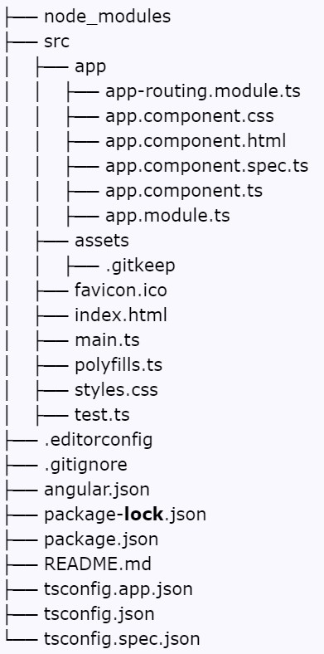
node_modules/
- Purpose: Contains all npm packages (libraries and dependencies).

- Example: When you install Angular Material (npm install @angular/material), its code is stored here.

📁 src/
- Purpose: Source folder for your actual app code.

- Everything you build lives here.

Inside src/:

📁 app/
- Purpose: Main app logic—components, modules, routing.

- You can think of this as your core app container.

📄 app.module.ts
- This is the root module that tells Angular how to build and run the app.

Example:
ts
CopyEdit
import { NgModule } from '@angular/core';
import { BrowserModule } from '@angular/platform-browser'; import { AppComponent } from './app.component';

@NgModule({
declarations: [AppComponent], imports: [BrowserModule],
bootstrap: [AppComponent]
})
export class AppModule { }
●
📄 app.component.ts ● Main component logic.

Example:
ts
CopyEdit export class AppComponent {
title = 'my-angular-app';
}
●
📄 app.component.html
- Template (view/UI) for AppComponent.

Example:

html CopyEdit
<h1>Welcome to {{ title }}!</h1>
●
📄 app.component.css
- Styles for that component.

Example:
css
CopyEdit h1 {
color: teal;
}
●
📄 app.component.spec.ts
- Unit test file for the component.

Example:
ts
CopyEdit
it('should create the app', () => {
const fixture = TestBed.createComponent(AppComponent); const app = fixture.componentInstance; expect(app).toBeTruthy();
});
●
📄 app-routing.module.ts ● Routing configuration file.

- Defines how URLs map to components.

Example:
ts
CopyEdit
const routes: Routes = [
{ path: 'home', component: HomeComponent },
{ path: '', redirectTo: 'home', pathMatch: 'full' }
];
●

📁 assets/
- Purpose: Store images, icons, JSONs, fonts, etc.

- .gitkeep: Placeholder file to keep empty folders in Git.

Example: You can place an image logo.png here and use it in HTML:

html CopyEdit
<img src="assets/logo.png" />
●

📄 favicon.ico
- Icon shown in the browser tab.

- Replace this with your project logo if needed.

📄 index.html
- Main HTML page (single page in SPA).

- Angular renders your whole app inside <app-root>.

Example:

html CopyEdit
<body>
<app-root></app-root>
</body>
●

📄 main.ts
- Entry point of your Angular app.

- It bootstraps the root module.

Example:
ts
CopyEdit
platformBrowserDynamic().bootstrapModule(AppModule);
●

📄 polyfills.ts
- Helps your app work on older browsers by adding missing features.

- Example: Adds support for Promise, Array.includes, etc. in Internet Explorer.

📄 styles.css
- Global styles (shared across the app).

Example:
css
CopyEdit body {
font-family: Arial;
}
●

📄 test.ts
- Configures the testing environment for Karma (Angular’s test runner).

- Mostly used internally during testing.

Root-level config files

📄 .editorconfig
- Coding style rules for editors (indent size, line endings).

- Keeps consistency across different dev tools.

📄 .gitignore
- Tells Git which files to ignore (like node_modules, build files).

Example:

bash CopyEdit
/dist
/node_modules
●

📄 angular.json
- Main Angular CLI configuration file.

- Controls build, serve, and project structure.

- Example: You can add a new style file or configure build options here.

📄 package.json
- Lists all npm dependencies and scripts.

Example:

json
CopyEdit
"dependencies": {
"@angular/core": "^15.0.0",
"rxjs": "~7.5.0"
}
●

📄 package-lock.json
- Automatically generated.

- Locks exact versions of dependencies to ensure consistent installs.

📄 README.md
- Markdown file with project info.

- Shown on GitHub homepage.

Example: You can write:

md CopyEdit
## My Angular Project
This project is built with Angular 15 and shows a basic dashboard.
●

📄 tsconfig.json
- TypeScript compiler configuration.

- Sets rules for all .ts files.

📄 tsconfig.app.json
- TS config specific to the application code.

📄 tsconfig.spec.json
- TS config specific to test files (like .spec.ts).

Component in Angular ?
The Angular Component is the main building block of an Angular application.
The Angular Components are plain JavaScript classes defined using the @Component Decorator.

Every Decorator starts with @ symbol

@Component() decorator imports from @angular/core
The Component is responsible for providing the data to the View. Angular uses data binding to get the data from the Component to the View and vice versa.

Every Angular Application will have one root component which is
AppComponent

The Components consist of three main building blocks
- Template
- Class
- MetaData
Template :
The Template defines the layout and content of the View. Without the template, there is nothing for Angular to render to the DOM(Document Object Model).
There are two ways you can specify the Template in Angular.
- Defining the Template Inline @Component({ selector: ‘app-name’,
template: ` <h1>This is Header</h1>`,l

styleUrls: [‘./app.component.css’]
})
- Provide an external Template @Component({
selector: ‘app-name’, templateUrl: ‘./app.component.html’,
styleUrls: [‘./app.component.css’]
}) Class:

The Class provides the data & logic to the View. It contains the Typescript code
Class Contains the Properties & Methods. The Properties of a class can be displayed in the view using Data Binding.
The simple Angular Class
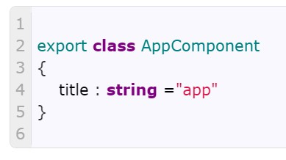

Meta Data :

Metadata Provides additional information about the component of Angular. We use the @Component decorator to provide the Metadata to the Component.

When Angular sees a class with @Component decorator, it treats the class as a Component.

Important Component metadata properties :
- Selector
The Angular looks for the selector in the template and renders the component there.
- Providers
The Providers are the Angular Services that our component is going to use
- Styles/styleUrls
The CSS styles or style sheets that this component needs. Here we can use either an external stylesheet (using styleUrls) or inline styles
(using Styles). The styles used here are specific to the component
- template/templateUrl
The HTML template that defines our View. It tells Angular how to render the Component’s view. The templates can be inline (using a template) or we can use an external template (using a templateUrl). The Component can have only one template. You can either use an inline template or an external template, and not both.
Creating a Component in Angular 8:
1 . To create a component in any angular application, follow the below steps:
● Get to the angular app via your terminal. ● Create a component using the following command: ng g c <component_name> OR ng generate component <component_name>

2. Create the Component Manually
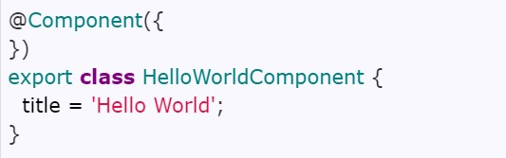
Add metadata to @Component decorator
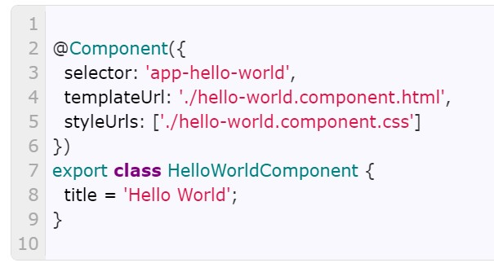

11Now Register the Component in Angular Root Module.
Module :

We have created the Angular Component. The next step is to register it with the Angular Module. Our application already has one Module, i.e., app.module.ts, which is also a root module.

Every Angular Application will have one root module which is
AppModule(app.module.ts)

The root module is the Module Angular loads when the App starts.

We use the @NgModule class decorator to define an Angular Module and provide metadata about the Modules. There are four important properties of @NgModule metadata. They are declaration, imports, providers & bootstrap.

We include the components, pipes, and directives part of this Module in the declaration array.

We add all the other Angular Modules in the imports array.

Include all the angular services part of this Module in the providers array.

The Component which we will give in the bootstrap array will load first.
Z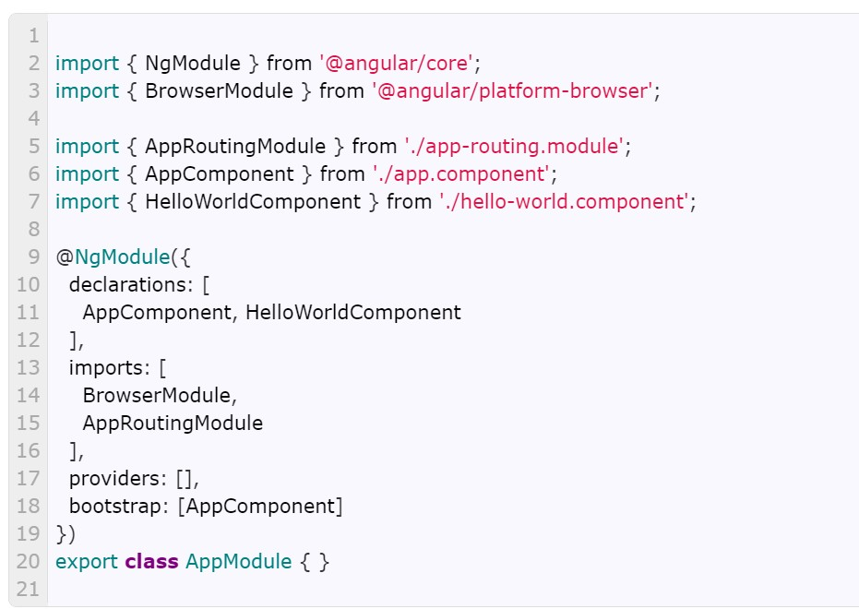

NOw Component is Ready

11 Different types of decorators(Annotations) in angular
Decorators are special functions prefixed with @ that attach metadata to classes, properties, methods, or parameters — telling Angular what a class is and how it should behave.
Class Decorators:
- These decorators are applied directly to classes. They define the nature of the class and provide essential metadata.
  - @Component:
■ This is perhaps the most fundamental decorator. It marks a class as an Angular component, defining its view and behaviour.
■ It includes metadata like the component's selector, template, and styles.
○ @Directive:
■ This decorator is used to create custom directives, which add behavior to existing DOM elements.
○ @NgModule:
■ This decorator defines an Angular module, which organizes related components, directives, pipes, and services.
○ @Injectable:
■ This decorator marks a class as available for dependency injection, allowing it to be used as a service.
○ @Pipe:
■ Used to define pipes, that transform data in angular templates.
Property Decorators:
- These decorators are applied to class properties, modifying their behavior or providing metadata.
  - @Input:
■ This decorator declares an input property, allowing data to be passed from a parent component to a child component.
○ @Output:
■ This decorator declares an output property, enabling a child component to emit events that a parent component can listen to.
○ @HostBinding:
■ Binds a class property to a host element's property, attribute, or style — directly from inside the directive/component class, without touching the template..
○ @ViewChild & @ViewChildren:
■ These allow a component to get access to child components or DOM elements.
○ @ContentChild & @ContentChildren:
■ These allow a component to get access to elements projected into it by content projection.
Method Decorators:
- These decorators are applied to class methods, modifying their behavior or adding functionality.
  - @HostListener:
■ This decorator listens for events on the host element of a directive or component.
Parameter Decorators:
- These decorators are applied to constructor parameters, providing metadata about those parameters.
  - @Inject:
■ This decorator specifies a dependency that should be injected into the constructor.
○ @Optional, @Self, @SkipSelf, @Host:
■ These decorators modify how dependency injection resolves dependencies.

10. LifeCycle Hook Methods of Angular Components ?
Every Angular Application will go through the following lifecycle hook method in following order

https://youtu.be/H0MvUtxK5Sg?si=VJ30wQMBE7VwzhiS

- ngOnChanges()
- ngOnInit()
- ngDoCheck()
- ngAfterContentInit()
- ngAfterContentChecked()
- ngAfterViewInit()
- ngAfterViewChecked()
- ngOnDestroy()

ngOnChanges(){ } :
- This ngOnChanges() will be Called before ngOnInit() only if there are any Inputs are coming from its parent component - ● NOTE:
If your component is not receiving any input from the parent component , the framework will not call ngOnChanges().
ngOnInit() { } :

- It will be called when the component is getting initialized for the first time.
- Called once, after the first ngOnChanges(). ngOnInit() is still called even when ngOnChanges() is not (which is the case when there are no template-bound inputs).
ngDoCheck() { } :

- Called immediately after ngOnChanges() on every change detection run,

ngAfterViewInit() { }:
- It will be called once the component view (html) Initialized

ngAfterViewChecked() { }:
- It will be called if there any changes in html like updating the elements and changing the styles

ngAfterContentInit() { }:
- It will be called when projected content once initialized (projecting content means passing the html code form parent to child component )

ngAfterContentChecked() { }:
- It will be called when projected content gets updated
7
ngOnDestroy() { }:
- It will be called whenever we leaving from the component

To use these lifecycle hook methods we need to implements from Interfaces which are OnChanges , OnInit, DoCheck, AfterViewInit , AfterViewChecked, AfterContentInit, AfterContentChecked , OnDestroy

Example :
export class AppComponent implements OnDestroy , OnInit { ngOnDestroy() { console.log("Goodbye World!");
}
ngOnInit(){
console.log(“Component Initialized”)
}
}

- View encapsulation?

https://www.youtube.com/watch?si=h1SipexnbLlh2v14&v=7mRkFdLkFPw&featur e=youtu.be

r
- Pass the data between two components?
Angular, like any of the other major frontend frameworks, uses components as their central building blocks. The advantages of separation into logical units, especially with large applications, are great: code becomes more manageable, it improves readability, reusability, and maintainability.

How to pass data from one component into another one depends on their relationship with each other. The concept of parent-child-sibling relationship, which is essential when working with HTML, CSS and the DOM, applies also to components in Angular, or any other frontend framework.

        - Parent to Child
        - Child to Parent
        - Child to Child
        - Un-related components m

Parent to Child Communication:

in the parent component:
      - Create a variable that stores the data. currentMsgToChild1 = ‘’;
      - Use double-binding with [(ngModel) ]for the newly created variable.
<input type=”text” [(ngModel)]=”currentMsgToChild1">
      - Add the child template and use property binding to assign the variable to the property.
<app-child1
[msgFromParent1]=’currentMsgToChild1'></app-child1>
in the child component:
      - Declare a variable with the @Input decorator. @Input() msgFromParent1: any[];
      - Render the data in the template.
<p>{{ msgFromParent1 }}</p>

Passing Data fromChild Component to Parent Component:
We can pass the data from child to parent in two ways one using
@ViewChild() Decorator and another one using @Output() decorator
● Passing data from child to parent using @ViewChild( ) Decorator
@ViewChild() is a property decorator - It gives the parent access to all the attributes and functions of the child component. Steps to pass data from child to parent using @ViewChild( ) in the parent component:
      - Import ViewChild() and ngAfterViewInit() and implement the lifecycle hook.
import { ViewChild, AfterViewInit } from ‘@angular/core’; export class AppComponent implements AfterViewInit {…} ngAfterViewInit() {}
      - Import the child component. import { Child1Component } from ‘./child1/child1.component’;
      - Use the @ViewChild() directive.
@ViewChild(Child1Component, {static: false}) child1:
Child1Component;
      - Declare a variable that holds the data. msgFromChild1: any;
      - In ngAfterViewInit() call the variable that holds the data.
ngAfterViewInit() {this.msgFromChild1 =
this.child1.msgFromChild1; }
in the child component:
  - Create two variables, one that holds the data via double-binding and one that is an array.
currentMsgToParent=’’;
msgFromChild1 = [];
  - Create an input with double-binding for the newly created variable currentMsgToParent.
<input type=”text” [(ngModel)]=”currentMsgToParent”>
  - Use event binding to fire the function.
<button (click)=”msgToParent()”>send</button>
  - Create the function that pushes the value of the variable into the array.| msgToParent() {
this.msgFromChild1.push(this.currentMsgToParent); }
● Passing data from child to parent using @Ouput( ) Decorator

In child component:
- Declare a variable that is assigned to the @Ouput decorator which is set to a new EventEmitter().
@Output() callParent = new EventEmitter();
- Create a variable that holds the data.
currentMsgToParent = ‘cry, cry…’;
- Create a function that calls emit on the event with the data that we want to send.
msgToParent()
{this.callParent.emit(this.currentMsgToParent);}
- In the template create a button with a click event that calls the function. <button
(click)=”msgToParent()”>Cry</button> In the parent component:
  - Create a variable to hold the data. msg: string;
  - Create a function to receive the data, use $event as a parameter, and set it equal to the data variable.
getMsgFromBaby($event) {this.msg = $event;}
  - In the template use property binding to run the function whenever the event occurs.
<app-baby
(callParent)=”getMsgFromBaby($event)”></app-baby>

Passing Data from Two unrelated components in angular: We use BehaviourSubject to share the data with multiple components using a shared service.
For example, if we want to notify other components of the data change. Then we have to follow these steps.
In service.ts file
import { Injectable } from '@angular/core';

//1. Import BehaviorSubject from rxjs module
import { BehaviorSubject } from 'rxjs/BehaviorSubject'

@Injectable({
providedIn: 'root'
})
export class DataService {

//2. Create the data which we want to share with all the components
private msg= new BehaviorSubject(‘ ’);
//3. Now we want to send this message or data, so we create an observable
getMsg= this.msg.asObservable();

constructor() { }

//4. Create a method that updates the data (Behaviour Subject)
} updateMsg(){
this.msg.next(‘updated Message’);
}

13 . Load Components Dynamically ?
Component templates are not always fixed. An application might need to load new components at runtime

- NgComponentOutlet is used to load the components dynamically
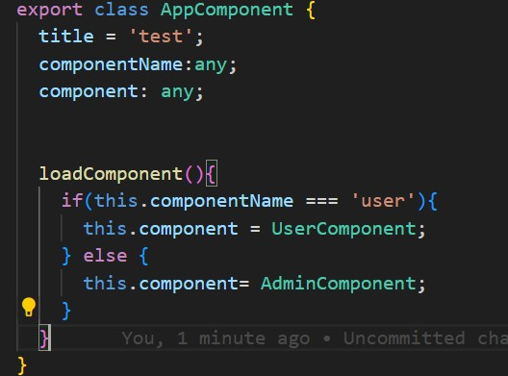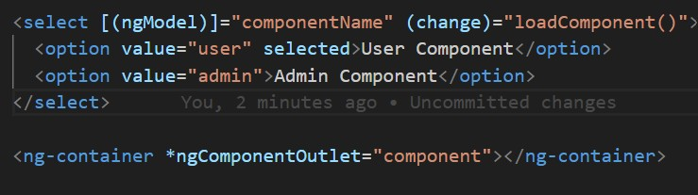

- *ngIf
- ViewContainerRef - which is also from angular core library where we can use to load the components dynamically

- a template?
Templates are written in HTML, and special syntax can be used within a template to build on many of Angular's features.
- interpolation?
Interpolation is used to display the value of variable in HTML which related to particular component
interpolation uses the double curly braces {{ and }} as delimiters.
EXamples :
  - <p>{{title}}</p>
  - <div><img alt="item" src="{{itemImageUrl}}"></div>
- Property / Attribute Binding ?
Property binding in Angular is used to set the values for properties of HTML elements or directives.
For example - disabling the button , passing the data from parent to child

To bind to an element's property, enclose it in square brackets, []

Mainly we will use property binding for setting the paths/url programmatically . below is one example Example : itemImageUrl = '../assets/phone.svg';
<img alt="item" [src]="itemImageUrl">

- Class and Style Binding ?
Use class and style bindings to add and remove CSS class names from an element's class attribute and to set styles dynamically.

Class Binding Syntaxes :
  - <tagname [ngClass]="{'class-name': user.status === ‘active’,
‘class-name2’:user.status === ‘inactive’}"></tagname>
  - <td [ngClass]="x > 0 ? 'blue' : 'green'">{{ x }}</td>
Style Binding Syntaxes :
  - [ngStyle]="isTrue ? {width: '50px', height: '20px'} : {}"
- Event Binding ?
Event binding listens and responds to user actions such as keystrokes, mouse movements, clicks, and touches.
Examples :
(click)="someFunction()"
(dblclick)="someFunction()"
(keyup)="someFunction()"
(keypress)="someFunction()"
(keydown)="someFunction()"
(mouseup)="someFunction()"
(mousedown)="someFunction()"
(mouseenter)="someFunction()"
(cut)="someFunction()"
(copy)="someFunction()"
(paste)="someFunction()"

- Two Way Data Binding ?
Two way data binding means if we make changes model / ts in the component are propagated to the view and that any changes made in the view are immediately updated in the component data.

Simply - Model to View and View to Model

The Angular uses the ngModel directive to achieve the two-way binding on
HTML Form elements

In-order use ngModel we have to import FormsModule in RootModule

<input type="text" name="value" [(ngModel)]="value">

- Pipes ?
Angular Pipes are used to transform the data from one form to another form
Ex: strings , dates , currencies.

Examples : json , uppercase , lowercase , date , async , decimal.

Async Pipe is Important

  - DatePipe: Formats a date value according to locale rules. - {{ dateVal | date }}
  - UpperCasePipe: Transforms text to all upper case.
  - LowerCasePipe: Transforms text to all lower case.
  - CurrencyPipe: Transforms a number to a currency string. - {{ amount
| currency:’INR’ }}
AsyncPipe: Subscribe and unsubscribe to an asynchronous source such as an observable. -
  - JsonPipe: Display a component object property to the screen as JSON for debugging.
How to do Chaining pipes / using multiple pipes. Below is example
{{ dateVal | date | uppercase }}

How to create our own / custom pipes
To create a custom pipe, first we need to create a pipe class. The pipe class must implement the PipeTransform interface. We also decorate it with @pipe decorator. Give a name to the pipe under name metadata of the @pipe decorator. Finally, we create the transform method,q which transforms given value to the desired output. See the below example how to create and use it Step1 :
import {Pipe, PipeTransform} from '@angular/core';
@Pipe({
name:’replace-with-a’
})

export class RelaceWithAPipe implements PipeTransform { transform(value: number, unit: string) { return value.replace(‘a’,’b’)
}
}

Step 2 : Declare in NgModule
@NgModule({
declarations: [AppComponent,ReplaceWithAPipe ],
imports: [BrowserModule,FormsModule,HttpModule],
bootstrap: [AppComponent]
})

Step3 : Now in app.component.html we can use that
<p>{{strVal | replace-with-a}} </p>

There are two kinds of pipes in Angular Pure Pipe and Impure Pipe .

Every Custom Pipe is Pure by default in angular .

inorder to make them Impure PIpe. we need to pass metadata as pure : false to @Pipe Decorator
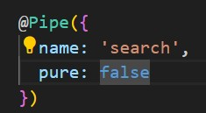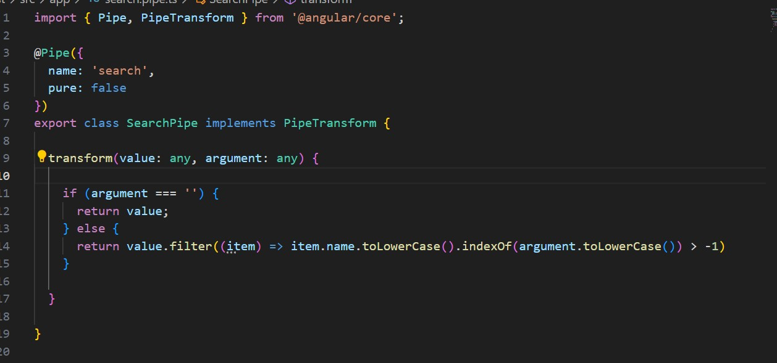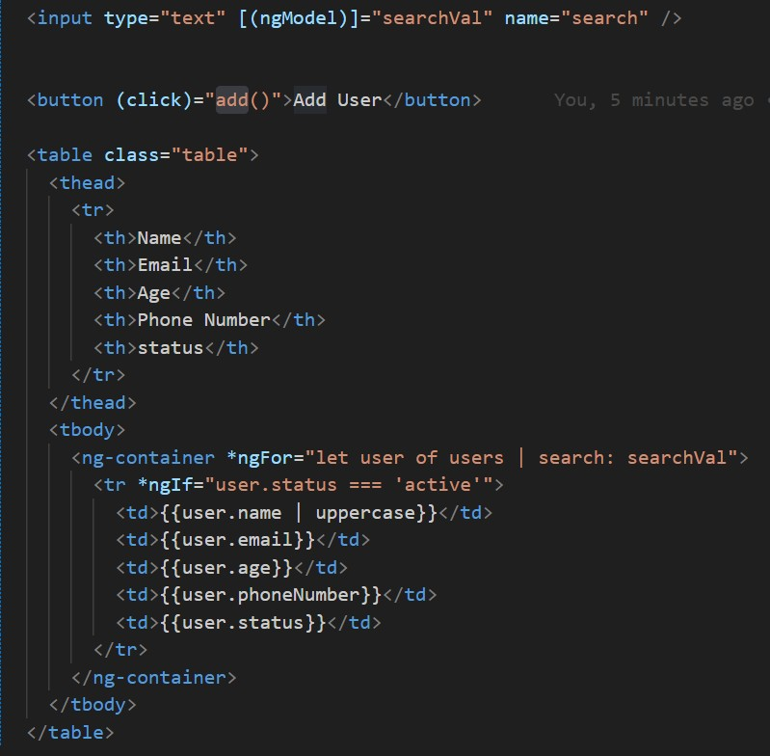

Difference between pure pipe and impure pipe ?

Pure pipe Impure pipe

The pure pipe will not run on every Change detection run
The pipe is executed on every change detection run

Pure pipe optimizes application Impure pipe may slow performance down your application

21. Directive?
Directives are classes that add additional behavior to elements in your Angular applications. Use Angular's built-in directives to manage forms, lists, styles, and what users see.

Difference between components and directives
Component are also one of the type of directive with the template
Directives are without the template

Components lifecycles ngOnChanges(), ngOnINit(), ngDoCheck(), ngDestroy() , lngAfterViewInit() , ngAfterViewChecked() , ngContentInit(), ngContentChecked()

Directive lifecycles ngOnChanges() , ngOnInit(), ngDoCheck() , ngOnDestroy()

There are three types of Directives :
- Components - Components are directives with Template (or view)
- Attribute Directives - ([ngClass] , [ngStyle] ,[(ngModel)]
- Structural directives - (*ngIf , *ngFor , *ngSwitch ) 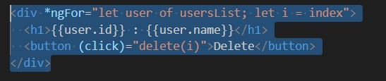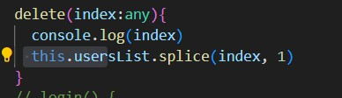● <h1 *ngIf="isShowForm">Register Form</h1>
●

<
h1

*ngIf
=
"!isShowForm"
>
Login

Form
<
/
h1
>

And also we can create our own / custom directives in angular

Creating Custom Directive : we can use ttClass as structural and attribute directive
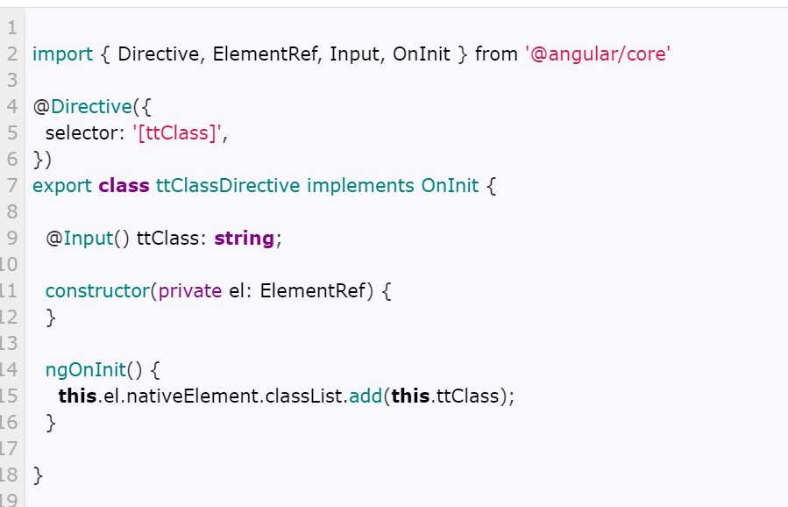

22. Service ?

A service is a class that is used to share the data across the application

How to create a service ?

Ng generate service service-name

import { Injectable } from '@angular/core';

@Injectable({ providedIn: 'root',
})
export class HeroService {

}

Once we created a service we have to register in RootModule by using providers metadata
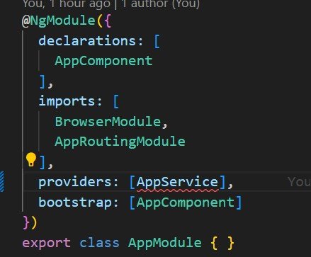

Or providedIn : ‘root’ ?

If its providedIn root - it will be available across the application - because it will register in Root Module

/* Registering the service in a @NgModule will make it available in that
Module only (Singleton within the Module Scope) */

Inorder to use the above service- we need inject that into component by using dependency injection mechanism

constructor(heroService: HeroService){ }

Dependency Injection ?
Dependency Injection, or DI, is a design pattern and mechanism for delivering some parts of an application to other parts of an application .
it can be done by using the constructor(heroService: HeroService){ }
In order use services we will use this dependency injection concept

- . Singleton Service ?
A singleton service is a service for which only one instance exists in an app
We can create singleton service in two ways using providedIn: ‘root’ and registering in providers array in root module (app.module.ts) providers: [AppService]

- . a Standalone component , directive , pipe , module ?
Components, directives, and pipes can now be marked as standalone: true. Angular classes marked as standalone do not need to be declared in an NgModule (the Angular compiler will report an error if you try).

Ng g c component_name –standlone

@Component({
standalone: true, selector: 'photo-gallery', template: `
<h1>This is a Standalone Component</h1>
`,
})
export class PhotoGalleryComponent {
// component logic
}

We need not to register in Standalone components in Root Module
If we want to use one standalone component in another standalone component we need to pass a standalone component in @Component( ) decorator . see below
@Component({
standalone: true, selector: 'photo-gallery',
imports: [ImageGridComponent] ,//ImageGridComponent is a one more standalone component template: `
<app-image-grid><app-image-grid>
`,
})
export class PhotoGalleryComponent {
// component logic
}
- . How to Migrate an Existing Angular Project to Standalone ?
ng generate @angular/core:standalone

- . NgZone ?

ngZone is used the run the code outside of an angular application to improve the performance of the application

For Example if we are not depending upon the API response we can make that api call outside of angular application using ngZone
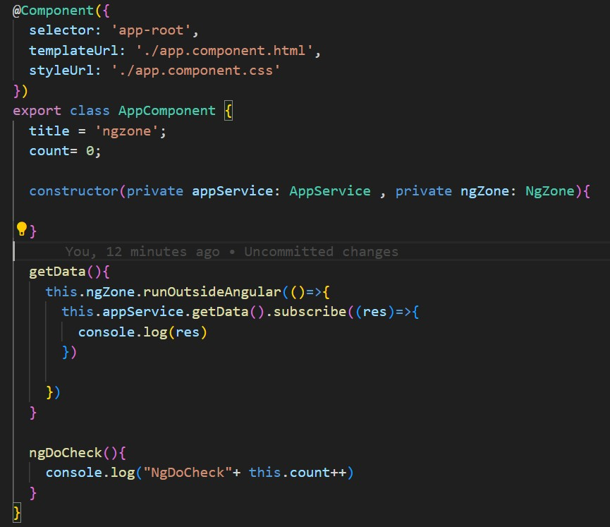

- a ChangeDetection Strategy ?

Change detection is the process where angular will check all the components from top to bottom if any state has changed - to update the DOM.

There are two types of strategies 1. OnPush
2. Default
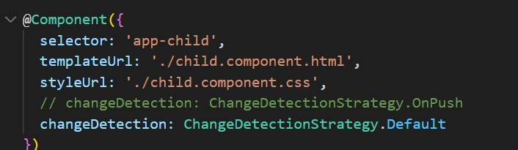
Its used to improve the performance of the application
  - ChangeDetectionStrategy.0nPush // it will check when the change in input and properties
  - ChangeDetectionStrategy.Default - by default it will be applied //it will check every change detections

- Angular Routing ?
Routing is used to navigate from page to another page without reloading the whole page called as single page application
In Angular routing is handled by RouterModule from @angular/router
The Router is a separate module in Angular. It is in its own library package, @angular/router.
Using Angular Router you can
  - Navigate to a specific view by typing a URL in the address bar
  - Passing parameters in routes
  - Protect the routes from unauthorized users using Route Guards

How to implement routing in an angular application ?
Setp : 1 : -
To make HTML5 routing work, we need to set up the “base href” in the DOM. This is done in the index.html file immediately after the head tag. <base href="/">

Step : 2
Next, create an array of route objects. Each route maps the path (URL
Segment) to the component - in this object

** wildcard entry

mport { NgModule } from '@angular/core';
mport { Routes, RouterModule } from '@angular/router';
mport { LoginComponent } from './login/login.component';
mport { HomeComponent } from './home/home.component';
mport { PageNotFoundComponent } from
./page-not-found/page-not-found.component';
mport { UserDetailsComponent } from
./user-details/user-details.component';
mport { isLoginGuard } from './is-login.guard';
const routes: Routes = [
{ path: 'login', component: LoginComponent },
{ path: 'home', component: HomeComponent, canActivate: [isLoginGuard]
,
{ path: 'user-details/:userId', component: UserDetailsComponent },
{ path: '', redirectTo: 'login', pathMatch: 'full' },
{ path: '**', component: PageNotFoundComponent },
;
In imports array we need to write RouterModule.forRoot(routes) i i i i i ' i ' i

}

]
@
NgModule
({

imports
:

[
RouterModule
.
forRoot
(
routes
)
]
,

exports
:

[
RouterModule
]
,

}
)

export

class

AppRoutingModule

{
}

Step

3

:

Import

router

module

and

pass

routes

object

in

forRoot

metho
d

[
RouterModule
.
forRoot
(
routes
)

Step4

-

we

have

to

update

the

path

by

using

routerLink

:

”active
”

<
li
><
a

routerLink
=
"/home"

routerLinkActive
=
"active"
>
Home
<
/
a
><
/
li
>

Step5 : once the path matches it will load in router-outlet
<router-outlet></router-outlet>

Main building blocks of Angular Routing : ‘
1 . Router - its a service - constructor(private router: Router){ } this.router.navigate([‘/login’]) - this is navigate to component on button click this.router.navigate([‘/user-details’ , val]) - this is navigate to
component on button click
- RouterOutlet - its a directive - this helps to load the view when pathmatches
<router-outlet></router-outlet>
- ActivatedRoute - its used to get the params from path import { Router, ActivatedRoute } from '@angular/router'; constructor(private activatedRoute:ActivatedRoute ) {
}
ngOnInit(){
let id:any =this.activatedRoute.snapshot.paramMap.get('id');

}
<router-outlet> in Angular
<router-outlet> is a placeholder where Angular loads components based on the route.
It enables Single Page Application (SPA) navigation.
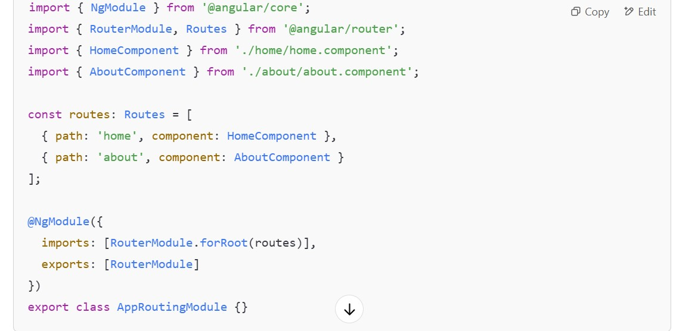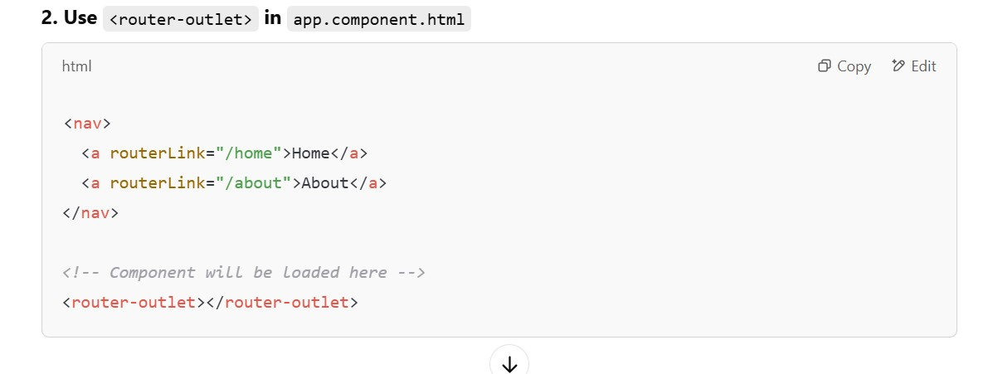
Server-Side Rendering (SSR) in Angular
Server-Side Rendering (SSR) generates Angular pages on the server instead of the browser.
Uses Angular Universal to improve SEO, performance, and first-page load speed.

29 . What are Angular Router Guards ?
Route Guards are used to restrict the user until the user performs specific actions like login.
There are 5 types of guards
- CanActivate
- CanActivateChild
- CanDeactivate
- Resolve
- CanLoad
Use cases for the CanActivate Guard
- Checking if a user has logged in
- Checking if a user has permission
One of the use cases of this guard is to check if the user has logged in to the system. If the user has not logged in, then the guard can redirect him to the login page.

Service file :

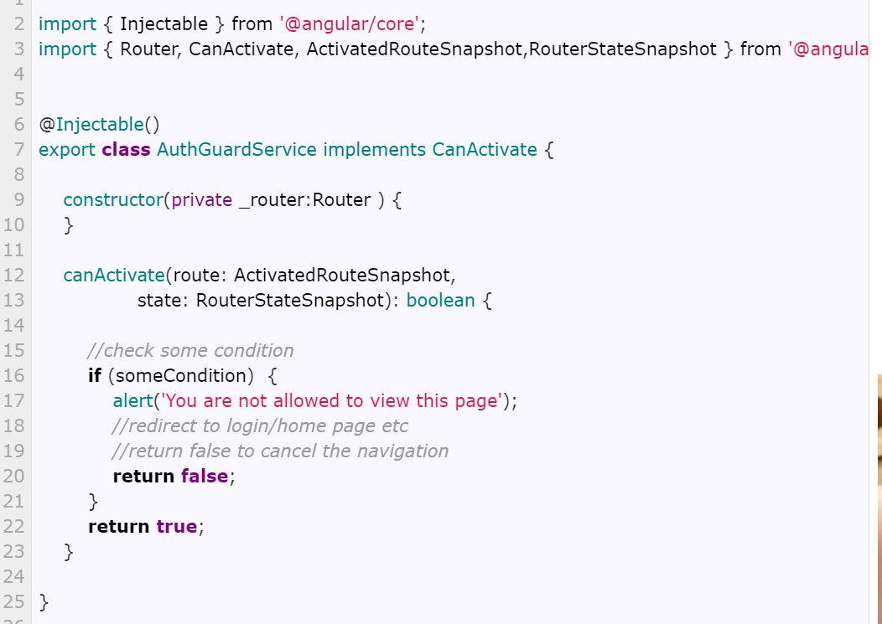

{

path
:

'produc
t'
,

component
:

ProductComponent
,

canActivate

:

[
AuthGuardService
]

}
,

Use Case for CanDeactivate

The best use case for CanActivate guard is the data entry component. The user may have filled the data entry and tries to leave that component without saving his work. The CanDeactivate guard gives us a chance to warn the user that he has not saved his work and give him a chance to cancel the navigation.

{

path
:

'register'
,

component
:

RegisterComponent
,

canDeactivate
:[
DeactivateGuard
]

}
,

Use Case for Resolve :
We can use this guard to fetch the data from the backend API, before navigating to other page

Use Case for CanLoad :

CanLoad and CanActivate both or same purpose but the main difference between them is CanActivate is only for component and
CanLoad for Module
{
path
:

"admin"
,

loadChildren
:
'./admin/admin.module#AdminModule'

,

canLoad:

[
SampleService
]
}
,

Use Case for CanActivateChild:
This

is

also

same

as

CanActivate

but

this

for

childRoutes

{

path
:

'product'
,

component
:

ProductComponent
,

canActivate

:

[
AuthGuardService
]
,

canActivateChild

:

[
AdminGuardService
]
,

children
:

[

{

path
:

'view/:id'
,

component
:

ProductViewComponent

}
,

]

}
,

30 . Lazy Loading in Angular ?
The Angular apps get bigger in size as we add more and more features. The Angular Modules help us to manage our app by creating separate modules for each new feature. But, as the app gets bigger in size, slower it loads. That is because angular loads the entire application upfront.

LazyLoading is the concept of loading the modules whenever that module is required. Instead of loading all modules all at one time. We can achieve this

{path: "admin", loadChildren: ()
=>import('./admin/admin.module').then(m => m.AdminModule) ,
canLoad: [AdminService]},

In order to implement to this lazy loading :
We have to create module by using the command
ng g module module-name (auth) –routing
This will generate two files like auth.module.ts and auth.routing.module.ts

Since this module is required two components as per our requirement like login and registration so we have to two create two component login and registration

After that we have to register them in auth.module.ts

Once that is done we have to create routes array for those two components in auth.routing.module.ts and that routes array we have to pass in forChild(routes)

And then we have to set the path for auth module in app.routing.module.ts file like below

Once the path is matched it will load that module with the help of router-outlet
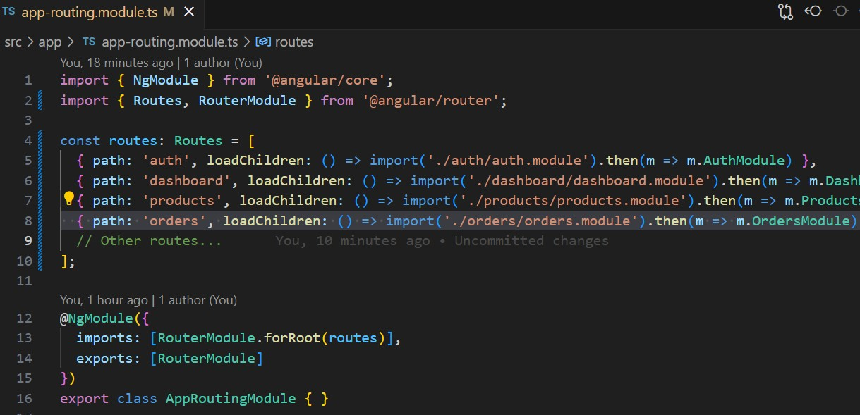

auth.module.ts file
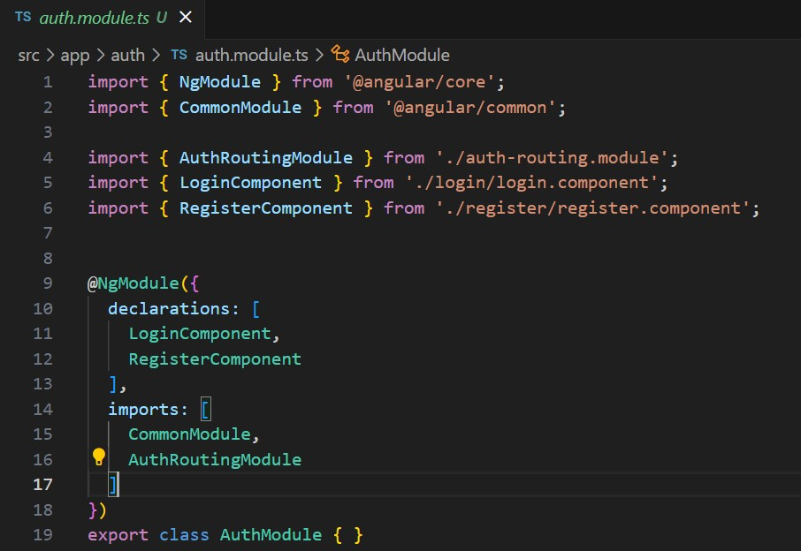

auth.routing.module.ts
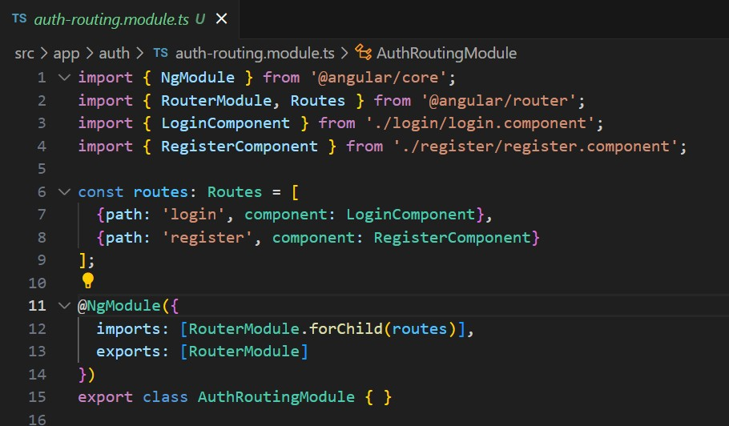

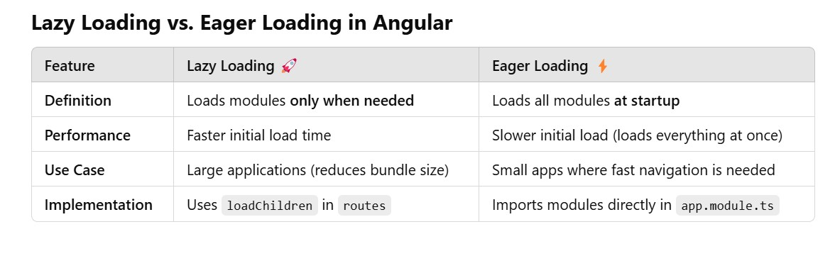

31 . What are Angular Forms ?

In general , forms are used to take the data from User.
In order to validate the forms in angular there are two approaches .
1.template driven form validation
2.Reactive form validation

Inorder to implement template driven form validation
Step 1 : we have to import FormsModule in app.module.ts in imports metadata array
Step 2 : write html form with ngForm
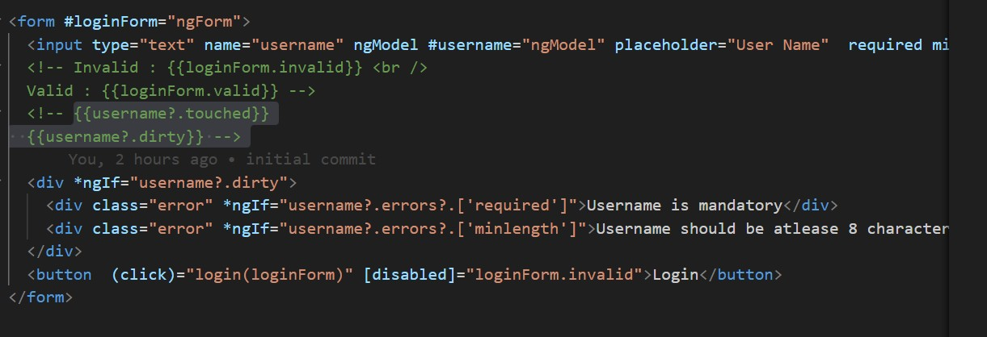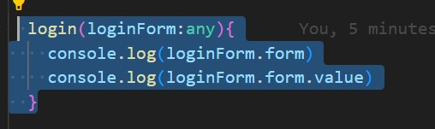

Template Driven Form Validation
In Template Driven Forms we specify behaviors/validations using directives and attributes in our template and let it work behind the scenes. All things happen in Templates hence very little code is required in the component class. This is different from the reactive forms, where we define the logic and controls in the component class.
The Template-driven forms
- The form is set up using ngForm directive
- controls are set up using the ngModel directive
- ngModel also provides the two-way data binding
- The Validations are configured in the template via ngMpde; directive
Template-driven forms are
- Contains little code in the component class
- Easier to set up While they are
- Unit testing is a challenge
- Not reusable

To work with Template-driven forms, we must import the
FormsModule. We usually import it in the root module or in a shared module. The FormsModule contains all the form directives and constructs for working with forms
Open the app.module.ts and add the import { FormsModule } from '@angular/forms'; to it.
And also add the FormsModule to the imports metadata property array

We have to use ngForm Directive for form tag

Reactive Form Validation :
To work with Reactive forms, we must import the
ReactiveFormsModule. We usually import it in the root module or in a shared module
Then <form [formGroup]="contactForm"> With FormGroup :
contactForm = new FormGroup({

firstname
:

new

FormControl
(
‘’

,

[
Validators.required]),

lastname
:

new

FormControl
(
‘’

,

[
Validators.requir
ed]),

email
:

new

FormControl
(
‘’

,

[
Validators.required])
,

gender
:

new

FormControl
(
‘’

,

[
Validators.required]),

isMarried
:

new

FormControl
(
‘’

,

[
Validators.require
d])
,

country
:

new

FormControl
(
‘’

,

[
Validators.required
]
)

}
)

onSubmit
()

{

console
.
log
(
this
.
contactForm
.
value
)
;

}

With

FormBuilder

:

In ts file :
import { FormBuilder } from '@angular/forms'; contactForm:any;
constructor(private formBuilder: FormBuilder) { this.myForm()
}
myForm(){
this.contactForm = this.formBuilder.group({
firstname: [''],
lastname: [''],
email: [''],
gender: [''],
isMarried: [''],
country: [''],
});
}

onSubmit
()

{

console
.
log
(
this
.
contactForm
.
value
)
;

}

Difference between template driven forms and reactive forms ?
- Template-driven forms make use of the "FormsModule", while reactive forms are based on "ReactiveFormsModule".
- In a template-driven approach, most of the logic is driven from the template, whereas in reactive-driven approach, the logic resides mainly in the component or typescript code. Let us get started by generating a component and then we'll update our form code.
- Template-Driven forms are used for simple forms and Reactive-driven forms are used bigger forms
the Difference between FormGroup and FormBuilder ?
Using FormBuilder over FormGroup helps to improve application performance.
FormGroup will new FormControl - means it will create new object for each form control
this.form1 = new FormGroup({}) c
FormBuilder(helper class)
● creating FormBuilder object (Removing 'new' keyword) ● it needs to be injected in constructor constructor(private _fb:FormBuilder) { } this.form1 = this._fb.group({})

Difference between setValue() and patchValue
Angular Forms has three main building blocks i.e FormControl, FormGroup & FormBuilder. All these components have methods setValue & patchValue and behave differently
We use the SetValue to update the FormControl , FormGroup . When we use it to update the FormGroup the SetValue requires that the object must match the structure of the FormGroup exactly. Otherwise, it will result in an error.
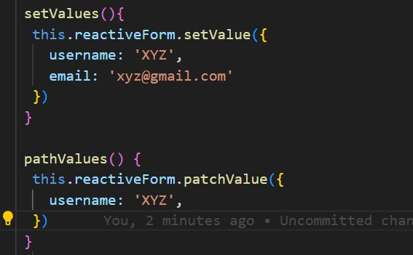
The

PatchV
alu
e

is

used

to

update

only

a

subset

of

the

elements

of

e
t
h

For
mGrou
p
.

It

will

only

update

the

matching

objects

and

ignore

th
e

rest
.

Validators :
Validating the Forms is very important, otherwise, we will end up having invalid data in our database. The Angular Forms Module provides a few built-in validators to help us to validate the form. They are listed below.
lastname: new FormControl('',[Validators.maxLength(15),
Validators.pattern("^[a-zA-Z]+$") , Validators.email , Validators.required]),

- Required validator
- Min length Validator
- Max length Validator
- Pattern Validator
- Email Validator

We also can create our own custom Validator :
Built-in validators are useful but do not cover all use cases. This is where we use the custom validator. It is very easy to create a custom validator in Angular.
Create one custom ts file . name of custom validator is ValidateUrl
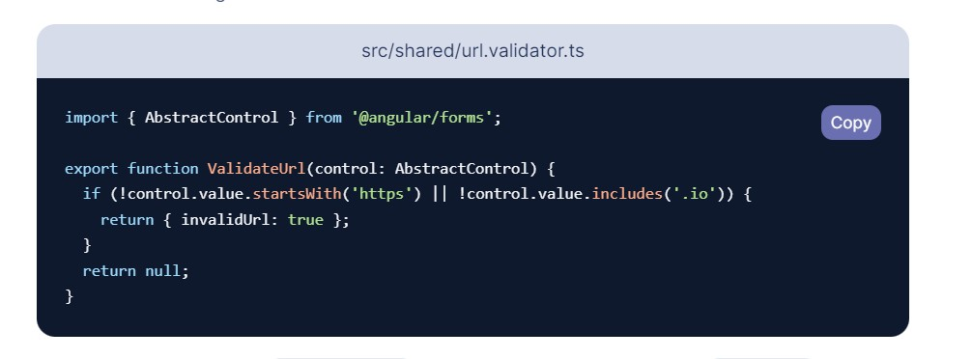
The above code uses the Notice AbstractControl class, which is the base class for FormControls, FormGroups, and. This allows access to the value of the FormControl.
Then in component.ts file
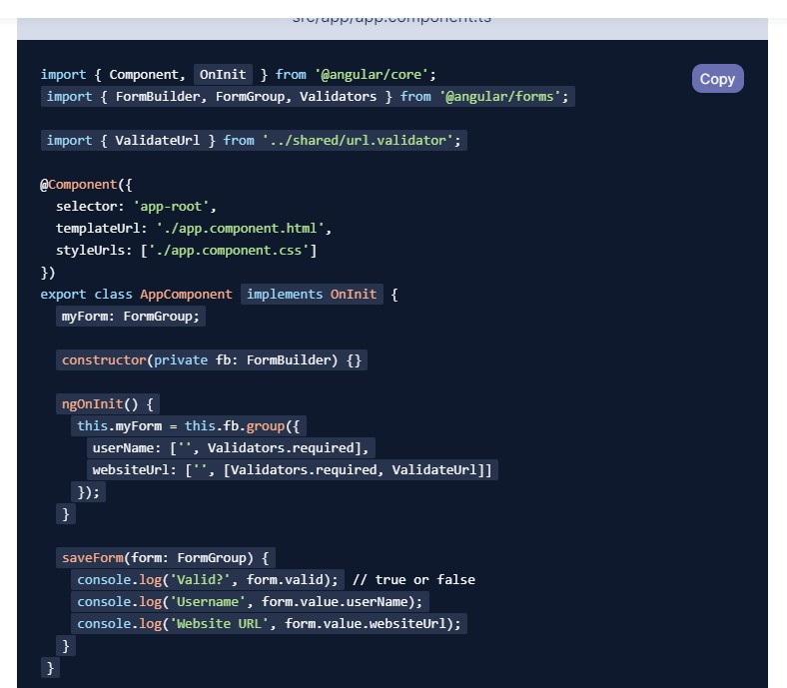

Using Angular HttpClient
The HttpClient is a separate model in Angular and is available under the @angular/common/http package. The following steps show you how to use the HttpClient in an Angular app.
There are four methods in http , get ,post,put , delete ,
Import HttpClientModule in Root Module
We need to import it into our root module app.module. Also, we need to
it

to

the

import
s

metadata

array
.

import

{

NgModule

}

from

'@angular/core'
;

import

{

HttpClientModule

}

from

'@angular/common/http'
;

@
NgModule
(
{

declarations
:

[

AppComponen
t

]
,

i
mports
:

[

HttpClientModul
e

]
,

providers
:

[]
,

bootstrap
:

[
AppComponent
]

}
)

export

class

AppModule

{

}

Import Required Module in Component/Service
Then you should import HttpClient the @angular/common/http in the component or service.
1
2  3 | import { HttpClient } from '@angular/common/http';
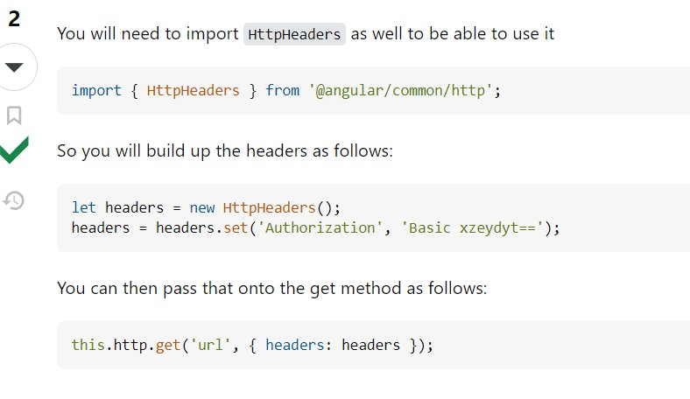
Inject

HttpClient

service

Inject

the

HttpClient

service

in

the

constructor.

1
2

3

4

constructor
(
public

http
:

HttpClient
)

{

}

Call

the

HttpClient.Get

method

Use

e
Http
Client.G
t

m
ethod

to

send

an

HTT
P

Reques
t
.

The

request

is

sent

wh
en

w
e

Subscrib
e

to

the

get(
)

method.

When

the

response

arrives

map

it

the

desire
d

object and display the result.
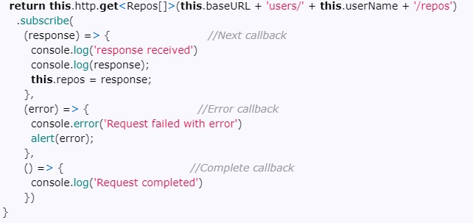
What is HttpInterceptor ?
HttpInterceptor is used to handle HTTP requests and Error handling globally within an application.
Mostly we will use http interceptor for sending authentication token header by cloning the requested header in http interceptor
.ng g interceptor interceptor-name
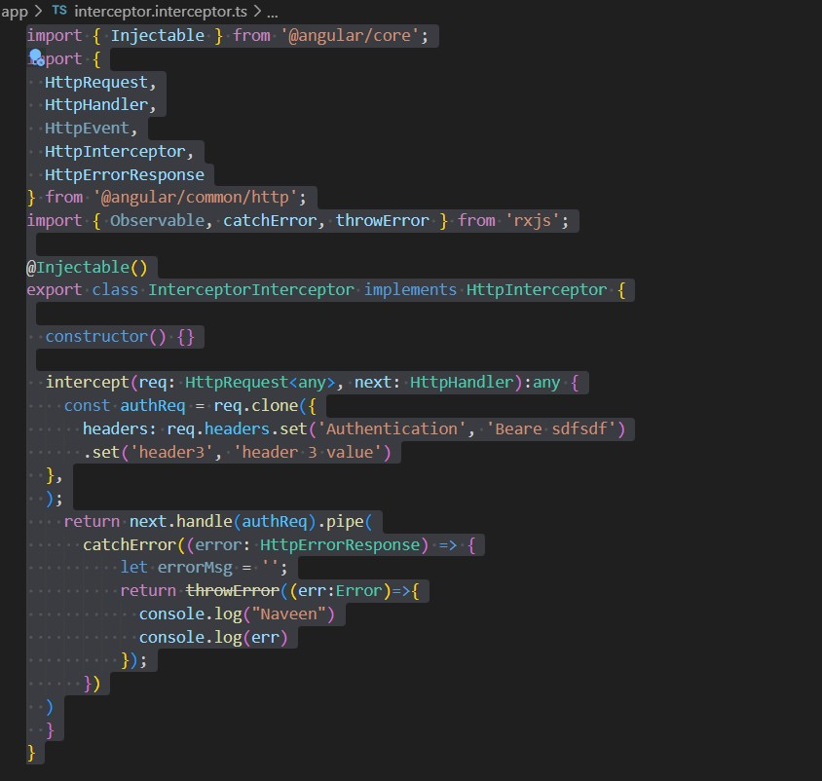

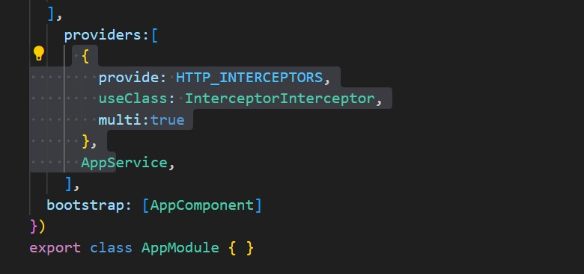

The

HttpReq
ues
t

contains

URL,

method,

headers,

body,

and

other

reques
t

configuration
.

The

Htt
pHandle
r

dispatches

the

HttpReques
t

to

the

next

Handler

using

e
th

method

HttpHandler.handle
.

How many ways we can send JWT token to API

The ways to send a JWT token to an API, here are the primary methods:
Authorization Header (Bearer Scheme):
○ This is the most common and recommended approach. The token is included in the Authorization header with the Bearer scheme.
HTTP-only Cookies:
○ This is considered the most secure method. The server sets the token as an HTTP-only cookie, which the browser automatically includes in subsequent requests.
Local/Session Storage (with caution):
○ While less secure, the token can be stored in local or session storage and then manually added to the Authorization header in each
request. However, this method is vulnerable to XSS attacks, so extra security precautions are needed.
Therefore, those are the three main ways.

@ViewChild() @ViewChildren() @ContentChild() @ContentChildren()?
@ViewChild() is a decorator from angular/core library - mainly its used to get the template element references and to access the child component methods and variables v
@ContentChild() is a decorator from angular/core library - mainly its used to get the template element references of the projected content
@ViewChildren() is a decorator from angular/core library - mainly its used to get the multiple template element references
@ContentChildren() is a decorator from angular/core library - mainly its used to get the multiple template element references of the projected content

src/app/parent/parent.component.html
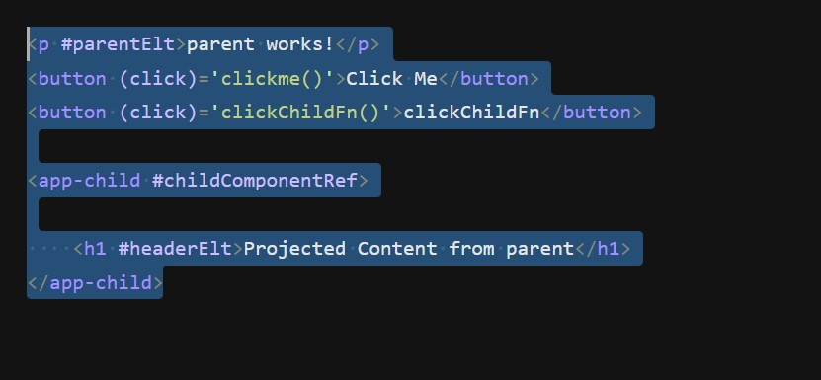
parent.component.ts
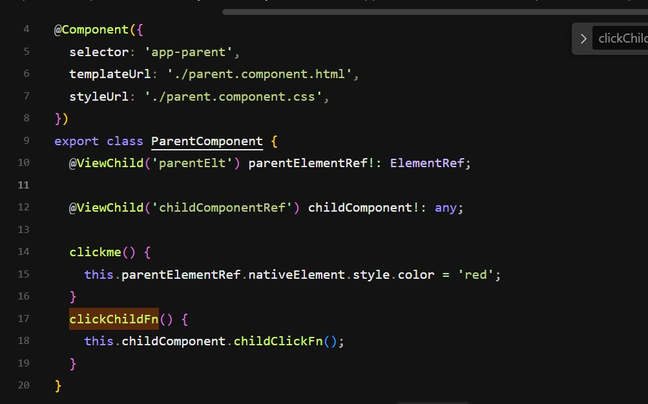

Child.component.html
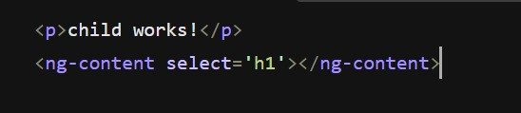

Child.component.ts
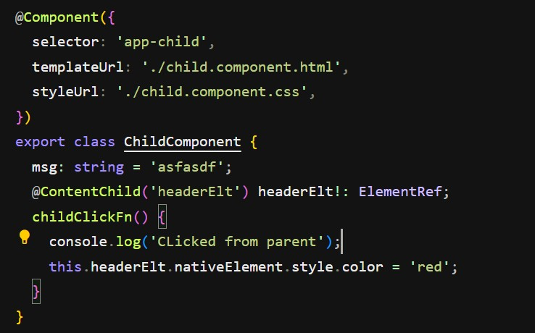

@ViewChild() Static true and false?
When you use static true for ViewChild you can access the template reference at
the time of ngOnInit() and ngAfterViewInit()

When you use static false for ViewChild you can access the template reference at
the time ngAfterViewInit() only not at ngOnInit()

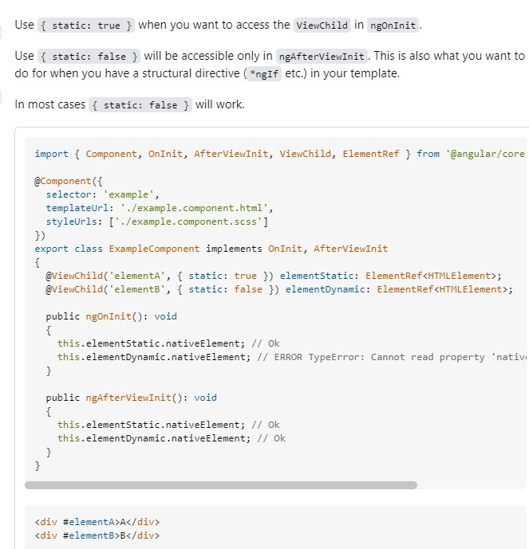

Difference between constructor() { } and ngOnInit(){ }
constructor() is a special method for class that is executed when the class is instantiated. In angular we mainly use this for dependency injection . it will be called first time before the ngOnInit()
ngOnInit() is an angular lifecycle hook method called by Angular when the component gets initialized . it will be called after the ngOnChanges()
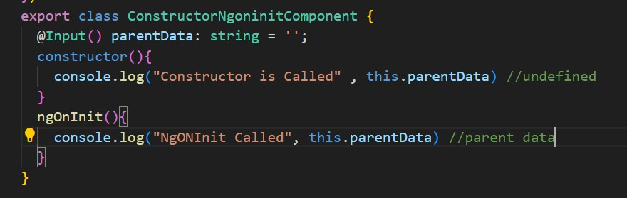

Difference between JIT and AOT Compiler ?
JIT - (Just in Time )
- It will Compile the code at runtime in the browser
- Because of the code is getting compiled at the time of runtime time - size of bundle will be larger
- Each file is compiled separately.
- Detect the template errors later at run time in the browser
- It will slow down the performance

AOT - (Ahead of Time)
- It compile the code at build time itself
- Because of the code is getting compiled at the time of build time itself - size of bundle will be smaller
- All code compiled together, inlining HTML/CSS in the scripts.
- Detect the template errors earlier at the time of compilation
- It will improve the performance
From angular 9 version we have new compiler called IVY compiler - which is popular one to improve the performance of the application by reducing the bundle side
To enable IVY - in tsconfig.json file - we need to configure as angularEnableIvy : ‘true’

What Files will generate when we run ng serve ?
Vendor.js file will have all third party code ,
Polyfills.js -it will have a piece of code that adds functionality to older browsers that have incompatibility issues.
Styles.css - all css code will be added in to this file
Main.js - all typescript code will be converted and added into this file
Runtime.js - it will be provide all these files to the browser for execution

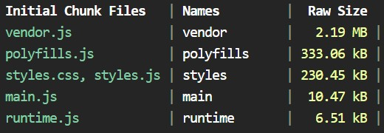

How to Improve the performance of the application ?
1 . By using the LazyLoading Concept
- By using the ChangeDetectionStrategy
- By Using the Pure pipes
- By using the TrackBy for *ngFor
Ex : 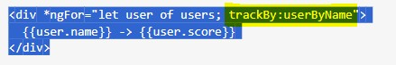
5.By removing unused variables and unwanted imports
- We need unsubscribe() to all observable while leaving from the component on ngOnDestroy( ) if required
- Removing the console.log() after debugging completed while giving the build 8. Running the build command with aot compiler : ng build --prod --aot - it will optimize the code

Implement caching for API responses.

What Scanners have you used for code scan ?
SonarLint and SonarQube Code Scanner
What are the new Angular Features ?
ViewChild static true to get elementRef at ngOnInit @Input({ required: true }) defaultColor: string; trackBy for ngFor
Guards has been changed to Functions in order to inject them we need to use inject()
Standalone component migration Support For Tailwind CSS increase Security
Increase the performance

Angular 16 Features
Signal-Based Reactivity (Experimental)
Improved Server-Side Rendering (SSR) with Hydration
Performance Improvements
Required Inputs for Components
Standalone API Enhancements
DestroyRef for Cleanup
Router Improvements
HttpClient with Fetch API esbuild Support for Faster Builds
Better TypeScript & Development Experience

Here are the major deprecations in Angular 16:
- provideZoneChangeDetection – No longer needed with the new reactivity model.
- APP_INITIALIZER returning a Promise – Prefer using Observables instead.
- TestBed.configureTestingModule without providers –
Enforces proper dependency injection setup.
- inject function inside lifecycle hooks like ngOnInit – Use it only in the constructor or factory functions.
- platformBrowserDynamic in standalone apps – Encourages bootstrapApplication instead.
- HttpClient using XMLHttpRequest – Replaced with Fetch API for better performance

RXJS and Operators ?

Why Use RxJS in Angular?
RxJS (Reactive Extensions for JavaScript) is used in Angular for handling asynchronous operations, event streams, and reactive programming. It helps manage data streams efficiently using Observables.
RxJS is essential in Angular for handling async data, state management, and event handling.
It improves performance using operators like debounceTime() and switchMap().
It makes code cleaner by eliminating callback hell.
Reactive Extensions for Javascript
Few operators from rxjs
- Observable
- Observer
- of
- from
- pipe
- map
- filter
- retry
- retryWhen
- take
- takeUntil
- debounceTime
- switchMap
- mergeMap
- concatMap
- exhaustMap
- forkJoin
- catchError
- throwError

Observable :
Observable is used to handle the stream of data. In order to get that stream data we need to subscribe ( ) to it otherwise it will not emit that data . to unsubscribe the observable we need call function unsubscribe()

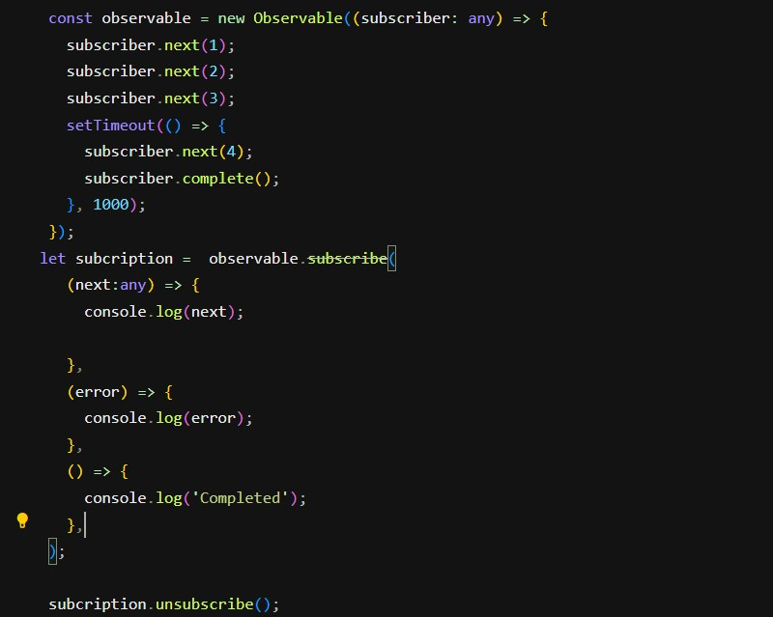

Interval() :-

The RxJS interval() operator returns an observable that emits a sequentially increasing number within the given interval of time.
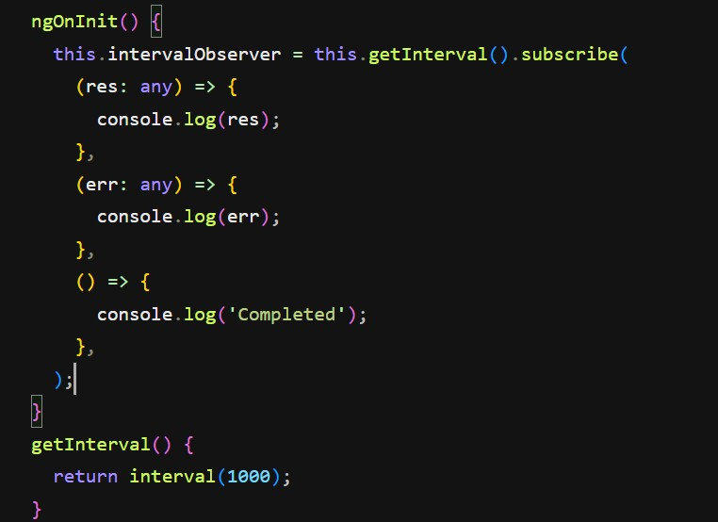

Difference between of() and from() operator ?
It is important to note the difference between of and from when passing an array-like structure (including strings):
Of would print the whole array at once.
From prints the elements 1 by 1.

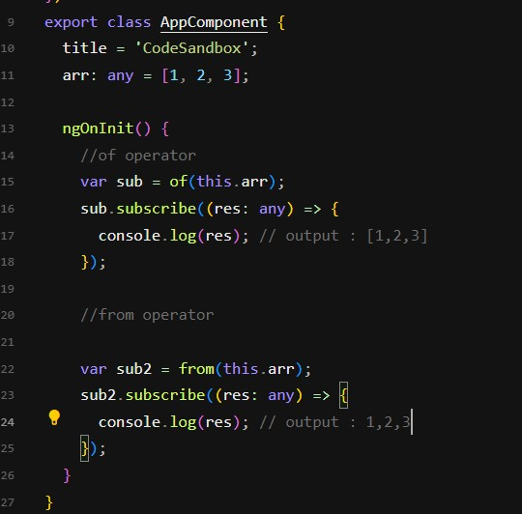

pipe() in rxjs :
pipe() function in RxJS: You can use pipes to link operators together. Pipes let you combine multiple functions into a single function.
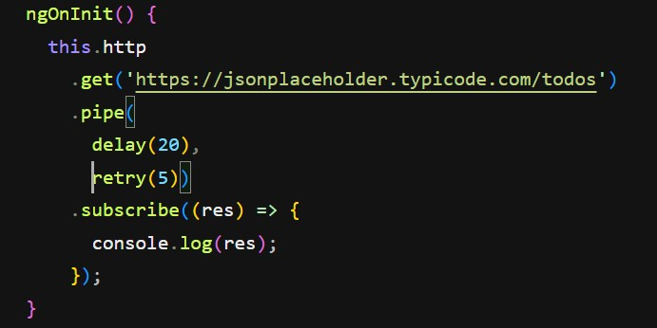

retry() :
Sometimes we will get an error as a bad gateway and it may also break due to a bad network connection also. When we want to retry again we can use retry () function

delay() / debounce() : it used to delay the API call for sometime. Mostly debounce() is used to implement the auto complete search functionality with the help of switchMap() too.

takeUntil() : mostly we will use the takeUntil to unsubscribe the observable on conditions. When we are leaving from the component or ( It is an RxJS operator that automatically unsubscribes from an Observable when another Observable emits a value ).
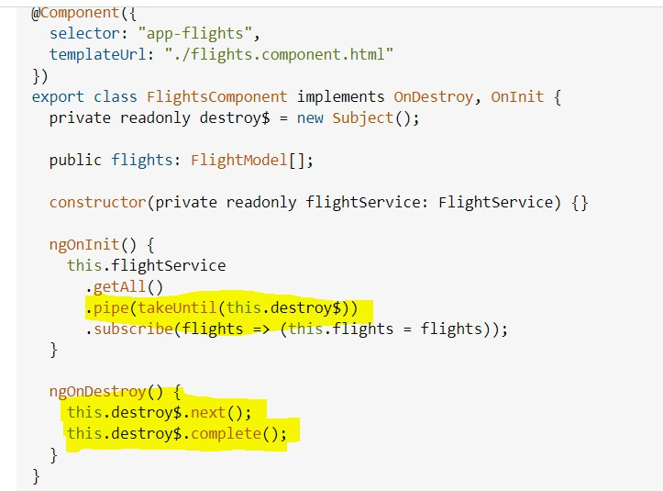

Merge() : instead of subscribing to each observable - we can subscribe to all observable at once mergeAll() : to merge all the Observable

takeUntilDestroyed() : mostly we will use the takeUntilDestroyed to unsubscribe the observable when we are leaving from the component. And also for this we need inject DestroyRef
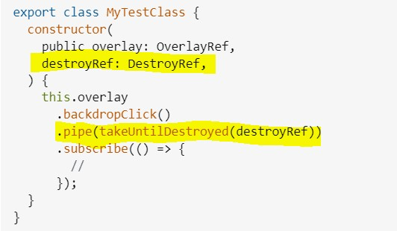

map() :map works exactly the same for Observables as it does for arrays. You use a map to transform a collection of items into a collection of different items.

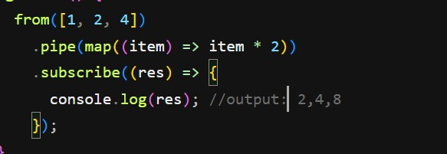

filter() : filter is used to filter out elements based on certain conditions.
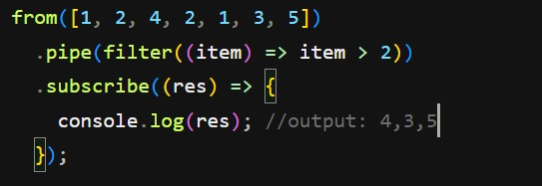

BehaviourSubject( ) vs Subject( ):
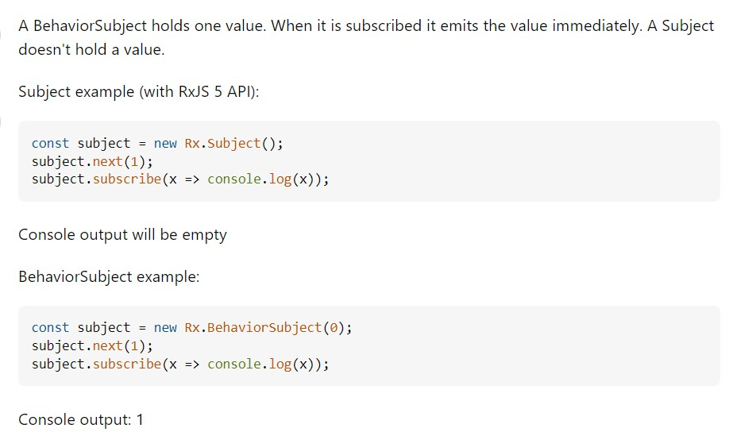
1. Subject
A Subject is a multicast observable. It doesn't store the last emitted value and it doesn't have a current value. When you subscribe to a Subject, it will only emit new values that are emitted after the subscription is made.
- No initial value: It doesn't have a default or initial value.
- Does not store the last value: If an observer subscribes after a value has been emitted, it won't receive any past value.
- Only emits values after subscription: Observers will only receive values that are emitted after they subscribe, not before.
Example: javascript Copy
import { Subject } from 'rxjs';

const subject = new Subject();

// Observer 1
subject.subscribe(value => console.log('Observer 1:', value));

subject.next(1); // Observer 1 will receive 1

// Observer 2 subscribes after the value 1 has been emitted
subject.subscribe(value => console.log('Observer 2:', value));
subject.next(2); // Observer 1 and Observer 2 will both receive 2

Output:
yaml Copy
Observer 1: 1
Observer 1: 2
Observer 2: 2

In this case, Observer 2 will not receive the 1 that was emitted before it subscribed. It will only receive 2, the next value emitted after it subscribed.

2. BehaviorSubject
A BehaviorSubject is a special type of Subject that requires an initial value and always stores the latest emitted value. Any new subscriber will always receive the most recent value immediately after subscribing, even if it was emitted before the subscription.
- Initial value: It needs to be initialized with a starting value.
- Stores the last emitted value: It always retains the latest value emitted, which is provided to new subscribers immediately.
- Emit the latest value to new subscribers: When a new observer subscribes, it gets the latest value (even if it was emitted before they subscribed).
Example: javascript Copy
import { BehaviorSubject } from 'rxjs';

const behaviorSubject = new BehaviorSubject(0); //
Initial value is 0

// Observer 1
behaviorSubject.subscribe(value => console.log('Observer 1:', value));

behaviorSubject.next(1); // Observer 1 will receive 1

// Observer 2 subscribes after the value 1 has been emitted
behaviorSubject.subscribe(value => console.log('Observer 2:', value));

behaviorSubject.next(2); // Both observers will receive 2

Output:
yaml Copy Observer 1: 0
Observer 1: 1
Observer 2: 1 // Receives the last emitted value when it subscribes Observer 1: 2
Observer 2: 2

In this case, Observer 2 will receive 1 immediately when it subscribes, because that's the latest value emitted before it subscribed. Then, both observers will receive 2 when it's emitted.

Key Differences:
Property | Subject BehaviorSubject
Initial Value | No initial value. Requires an initial value when created.
Last Emitted  Value | Does not store the last Stores and remembers the last emitted value. emitted value.
New  Subscribers | Will not receive any past Will receive the last emitted value value. when they subscribe.
Use Case | Useful when you don't Useful when you need the last known care about previous value available to new subscribers. values.
When to Use Which?
- Use Subject when you only care about the future values that will be emitted (i.e., no need to remember the last emitted value) ● No initial value: It doesn't have a default or initial value.
- Does not store the last value: If an observer subscribes after a value has been emitted, it won't receive any past value.
- Only emits values after subscription: Observers will only receive values that are emitted after they subscribe, not before.
●
- Use BehaviorSubject when you want to ensure that any new
subscribers always get the most recent value (or an initial value) as soon as they subscribe, even if they subscribe after the value has been emitted.

Summary:
- Subject: Multicasts values to all observers but does not retain the last emitted value. Observers will only receive future values.
- BehaviorSubject: Multicasts values to all observers and retains the most recent value. New subscribers will receive the last emitted value immediately upon subscription.
Get smarter responses, upload files and images, an

switchMap( ) vs mergeMap vs concatMap() vs exhaustMap( ):

SwitchMap only emits the latest observable value and unsubscribe() the previous observable.
flatMap/mergeMap collects all individual observables and returns all observables in a single array without caring about the order of observable. works asynchronously.
concatMap preserve the order and emits all observable value, works synchronously
exhaustMap - it will ignore all the observables while the previous Observable is not completed
forkJoin() :
To group the all the observables and it will wait for all to complete.if any observable throw an error - it will not work
One common use case for this is if you wish to issue multiple requests on page load (or some other event) and only want to take action when a response has been received for all’
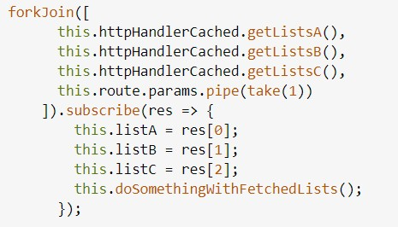

catchError () and throwError( ) :
catchError is used handle the errors this.http.get(“url”).pipe( catchError(this.errorHandler(error))
)
errorHandler(error:any){ return throwError(error.message)
}
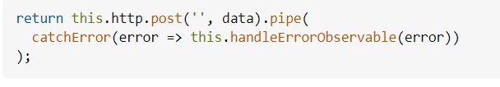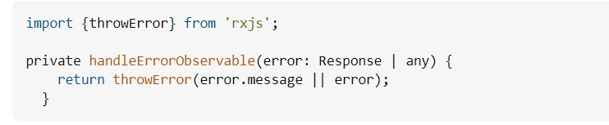

What is Tree shaking?
In Angular, tree shaking, combined with tools like Webpack, helps in reducing the bundle size by removing unused parts of the code (such as functions, variables, or modules) during the build process.

Difference between @Injectable and @inject
@Injectable : It makes a class as available dependency ( In other words, it will register your component as a dependency ) in injection context, so that you can inject ).

Eg : @Injectable ({ providerIn : ‘root’ })
export class UserService {
getUsers() {
return [‘alice’, ‘bob’]
}
}
@Inject : A function used to retrieve the registered dependency
Eg : private service = inject (UserService);

Difference between injecting dependencies using “ constructor(){}” and “@inject”
Constructor :
- Inheritance : child services must redeclare parent dependencies.
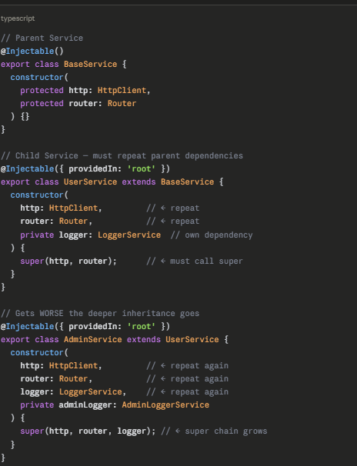
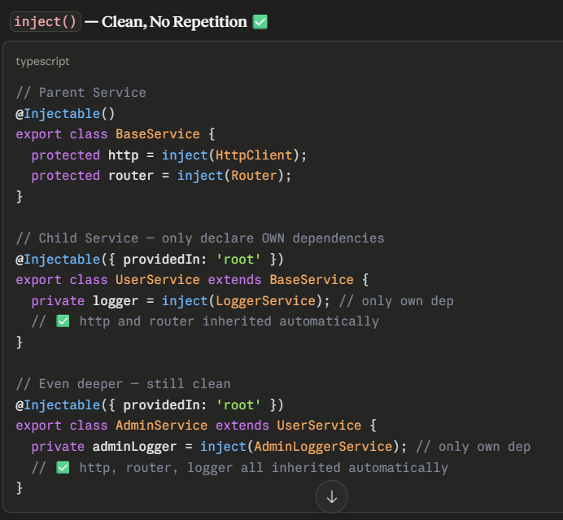

- Constructor — Cannot Work in Functions
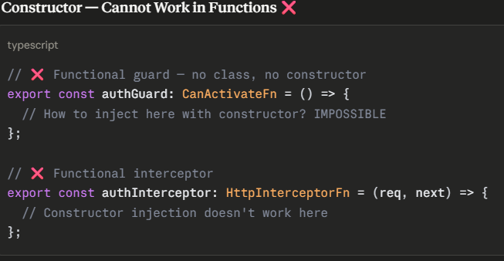
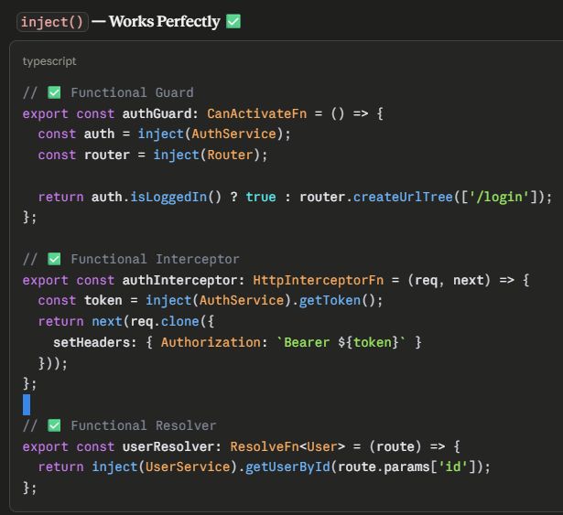

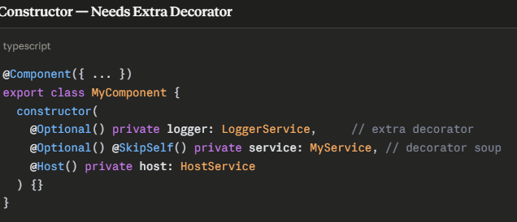
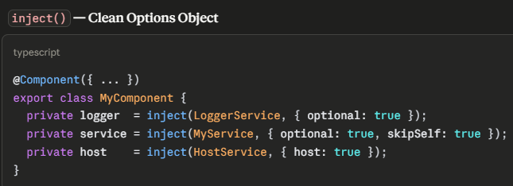
- Optional Dependencies

- Where to use
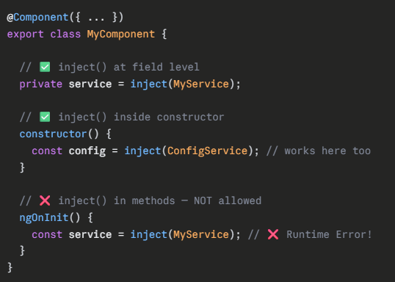

JAVA SCRIPT
1. var vs let operator ?
The difference between let and var is in the scope of the variables - when we create Variables declared by let are only available inside the block scope. Variables declared by var are available throughout the function / Global scope.

Var variables can be hoisted
Let variable can’t be hoisted
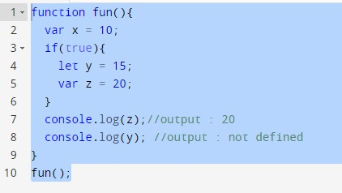

- . output of below of this code ?
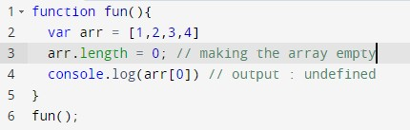
- . Difference between undefined and not defined ?
Undefined: It occurs when a variable has been declared but has not been assigned any value. Undefined is not a keyword.
Not defined : It occurs when we try to access any variable that is not declared

- . null vs undefined?
typeof null is object typeof undefined is undefined

5.Splice Vs Slice?

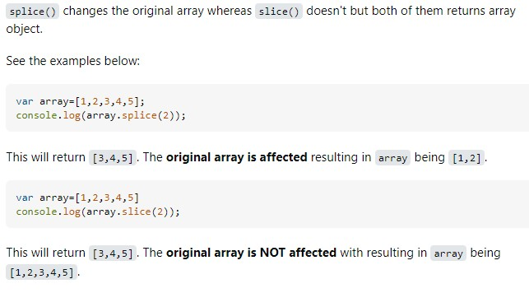

6. Map Vs Filter vs reduce?
The difference between map and filter method is that – map transforms each element of an array based on a transformation function and returns a new array of the same length, While, filter creates a new array with only the elements that satisfy a specified condition.

Reduce function will go through the each element in array and result into single value

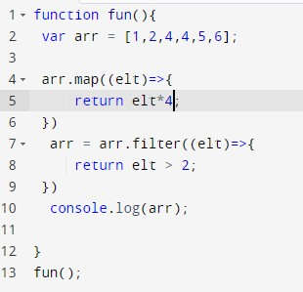

6. Hoisting ?
Hoisting is JavaScript's default behavior of moving all declarations to the top in global execution context.
This allows functions and variables to be used before they are declared.

7 . Recursive Functions ?
A function that calls itself is called a recursive function

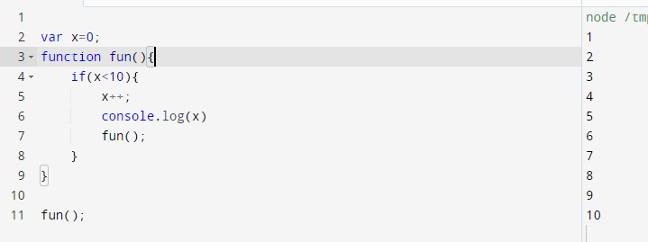
8 . the Callback function ?

Any function that is passed as an argument to another function is called as a callback function.
A JavaScript callback is a function which is to be executed after another function has finished execution.
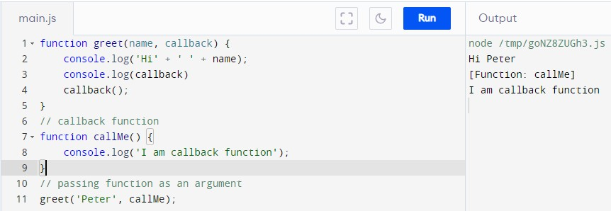
9 . Closures in javascript?
A closure is a feature of JavaScript that allows inner functions to access the outer scope of a function variables.

Lexical scope is the ability for a function scope to access variables from the parent scope. We call the child function to be lexically bound by that of the parent function.
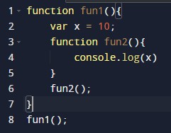

10. Observables Vs Promises?

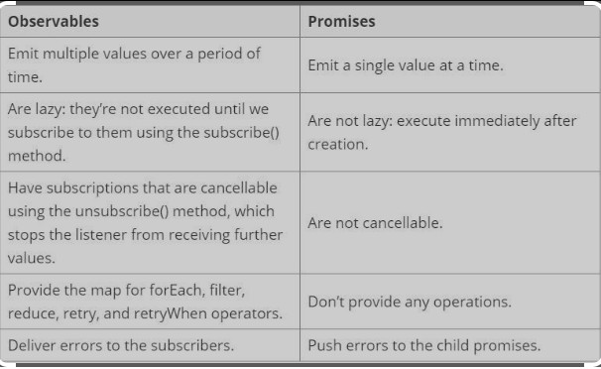

11 . call , apply and bind?

All three functions are used to borrow the function from another object .

Call() : The call() method calls the function with a given value and allows passing in arguments one by one separating them with commas:
apply() : The apply() method calls the function with a given value and allows passing in arguments as an array (or an array-like object).

bind() : The bind() method returns a new function and allows passing in a this array and any number of arguments.

let nameObj = { name: "Tony"
}
let PrintName = { name: "steve", sayHi: function (age) { console.log(this.name + " age is " + age);
}
}

PrintName.sayHi.call(nameObj, 42);
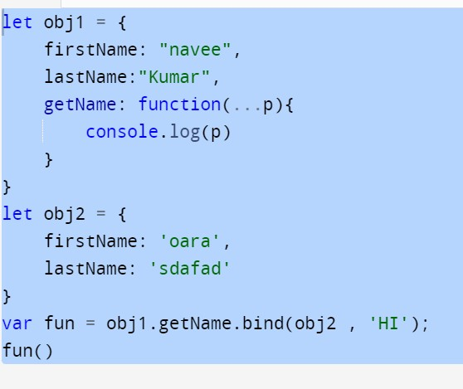

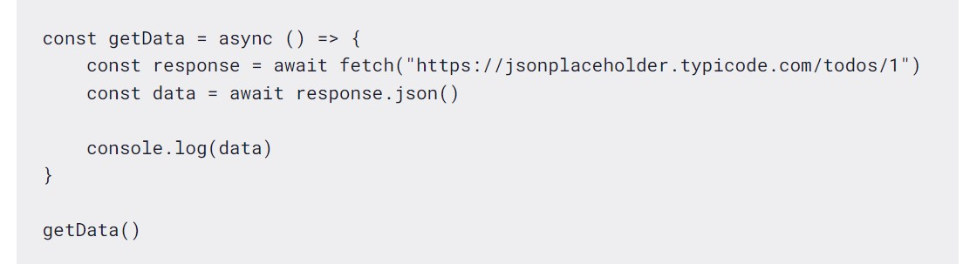
12

.

Async

/

Await

?

Async/await

is

a

JavaScript

feature

that

allows

you

to

write

asynchronous

cod
e

that

looks

and

behaves

like

synchronous

code
.

The

async

keyword

is

used

to

define

an

asynchronous

function.

An

asynchronou
s

function

is

a

function

that

returns

a

promise.

e
Th

awai
t

ke
d
ywor

i
s

use
d

o
t

t
wai

r
fo

a

promis
e

t
o

resolv
e

befor
e

executin
g

th
e

nex
t

lin
e

o
f

cod
e

‘use strict’ ;
Use strict is used to run the javascript code in strict mode only
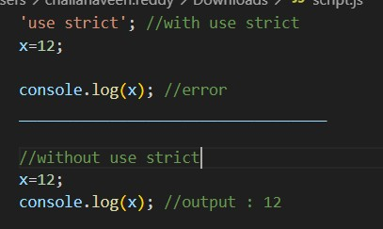

Why Use Asynchronous JavaScript?
JavaScript is single-threaded, so asynchronous programming allows:
Non-blocking execution (UI doesn't freeze)
Faster performance (multiple tasks run in parallel)
Efficient API calls, timers, and event handling
Ways to Handle Async Code
Callbacks → Leads to callback hell Promises → Improves readability async/await → Modern & cleaner approach
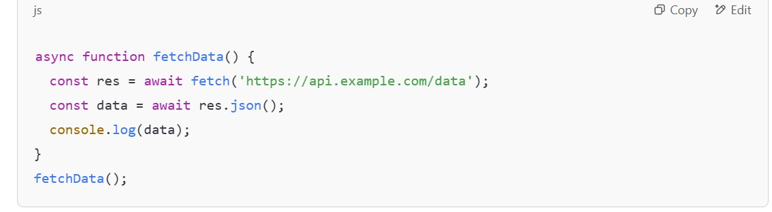
Asynchronous JavaScript keeps web apps smooth & fast!

Asynchronous: Code that runs in the background without blocking the main execution. Example: API calls, setTimeout.
✅ Promise: An object that represents a future value (either success or failure). Example: Fetching data from an API.
✅ async: A keyword that makes a function return a Promise automatically.
✅ await: A keyword used inside async functions to pause execution until a Promise resolves.

What is NaN in JavaScript?
✅ NaN (Not-a-Number) is a special value in JavaScript that represents an invalid number. It occurs when a mathematical operation fails or when trying to convert a non-numeric value into a number.

1. 13 . Regular function vs arrow functions ?
Inside a regular JavaScript function, this value is dynamic.
it means that the value of this depends on how the function is invoked. During a simple invocation the value of this equals the global object (or undefined if the function runs in strict mode)
this value inside of an arrow function always equals this value from the outer function
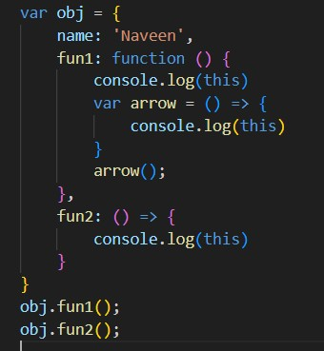

There is no arguments object in arrow function and arguments object will be there in regular function
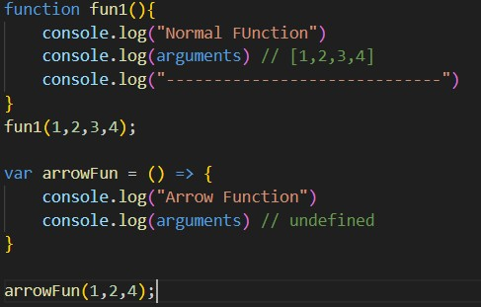

- . event bubbling and event propagation ?
Bubbling is the process of an event happening on a parent element when we click on a child element .
We can fix this by using event.stopPropagation();

- . Prototype in javascript ?

All JavaScript objects inherit properties and methods from a prototype:
The JavaScript prototype property allows you to add new properties to object constructors:

15.Difference Between Authorization and Authentication?

Authorization is the process of giving the Access to the user.
Authentication is the process of recognizing the user Identity.

16.CORS issue?
Cors issue will happen when a web page makes a request to a different domain.In order to overcome this issue we can use Access-origin-allow-control at Backend.

What is Transpiling in JavaScript (Angular)?
✔ Transpiling (or Transpilation) converts modern JavaScript/TypeScript code into an older version that browsers can understand.

- Why is Transpiling Needed?
Browsers don’t support all new ES6+ features.
Angular uses TypeScript, which needs to be converted into JavaScript. Ensures cross-browser compatibility.

- How Angular Uses Transpiling?
  - Angular uses TypeScript Compiler (tsc) to convert TypeScript → JavaScript.
  - Uses Babel or Webpack (internally) for optimization.

Why Use TypeScript Over JavaScript? 🚀
✅ TypeScript (TS) is a superset of JavaScript (JS) → It adds static typing, interfaces, and better tooling.
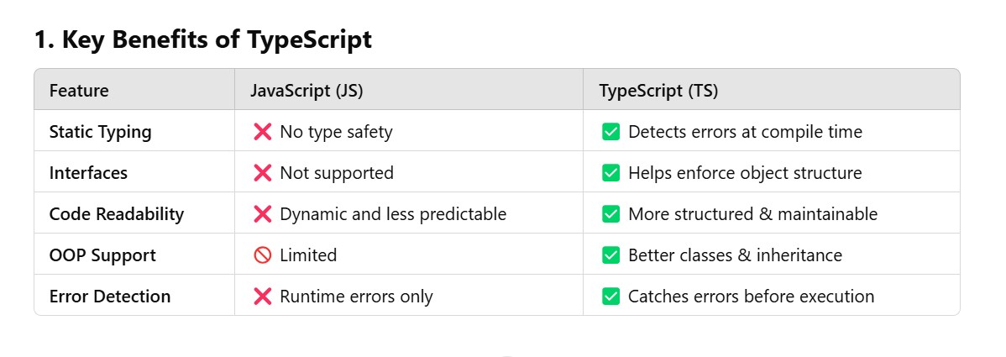

HTML

HTML : Hyper text markup language(it is the standard markup language for creating Web pages)and it consists of a series of elements

Structure of HTML:
<!DOCTYPE html>
<html>
<head>
<title>Page Title</title>
</head>
<body>

<h1>This is a Heading</h1>
<p>This is a paragraph.</p>

</body>
</html>

The <!DOCTYPE html> declaration defines that this document is an HTML5 document(it tells to the browser which markup version we are using)

What are the Schematic Elements?
Schematic elements are meaningful elements such as Header,footer,Img,Input Type,Button,Table.

SCSS/SASS

mixin and include?
The @mixin directive makes the CSS code to reuse;
The @include directive makes the mixin css code to include another class
@mixin important-text { color: red; font-size: 25px; font-weight: bold; border: 1px solid blue;
}
What are the Block level elements?
Block level elements display one by one.
ex:<div>
Inline Block level elements? It displays Side by Side.
ex:<span>
.danger {
@include important-text; background-color: green;
}

Variable is SASS ?
We also can declare variables in SASS
$myFont: Helvetica, sans-serif;
$myColor: red;
$myFontSize: 18px;
$myWidth: 680px;

body { font-family: $myFont; font-size: $myFontSize;
color: $myColor;
}

@extend in SCSS ?
The @extend directive lets you share a set of CSS properties from one selector to another.

.button-basic { border: none; padding: 15px 30px; text-align: center; font-size: 16px;
cursor: pointer;
}

.button-report { @extend .button-basic;
background-color: red;
}

How to add comments in CSS ?
/* content */

the ‘a’ in rgba mean?
h1 { color:rgba(R, G, B, A); }
R - red , G- Green, b-Blue , a - (alpha/opacity)

CSS HSL Colors?
Hue , Saturation, Lightness

20. What is the difference between CSS border and outline?
- CSS border properties allow us to set the style, color, and width of the border.
- CSS outline property allows us to draw a line around the element, outside the border.
23. Can we add an image as a list item marker?
To add an image as the list-item marker in a list, we use the list-style-image property in CSS.
Syntax:
list-style-image: url( ‘../’ );

28. What is CSS overflow?
The CSS overflow controls the big content. It tells whether to add scroll bars. The overflow contains the following property:
- visible
- hidden
- scroll
- auto
- Visible: The content is not clipped and is visible outside the element box.
- Hidden: The overflow is clipped and the rest of the content is invisible.
- Scroll: The overflow is clipped but a scrollbar is added to see the rest of the content. The scrollbar can be horizontal or vertical.
- Auto: It automatically adds a scrollbar whenever it is required.

To set Background image ?
    - background: white url('good-morning.jpg');
    - background-repeat: no-repeat;
    - background-attachment: fixed;
    - background-position: center;

Pseudo-elements:
    - ::before
    - ::after
Structural pseudo-classes:
    - :first-child
    - :nth-child(n)
    - :last-child
100vh vs100% ?
height: 100vh = 100% of the viewport height height: 100% = 100% of the parent's element height
Opacity?
The opacity CSS property sets the transparency to an element

Tweening in CSS ?
Tweening in CSS basically means animations -
It is the process of generating intermediate frames between two images In CSS3, the Transforms (matrix, translate, rotate, scale etc.) module can be used to achieve tweening.

div.a {
transform: rotate(20deg);
}
Explain the concept of Tweening in CSS - GeeksforGeeks

Z-index?

z-index is the CSS property that controls the stacking order of overlapping elements on a page.

How many ways can we define styles?
Inline - by using the style attribute inside HTML elements.
    - Internal - by using a <style> element in the <head> section.
    - External - by using a <link> element to link to an external CSS file.

Css Selectors?
Tag,id,class,universal
Box model?
In Css Box model is a container that contains content-padding-border-margin

PSEUDO Classes :
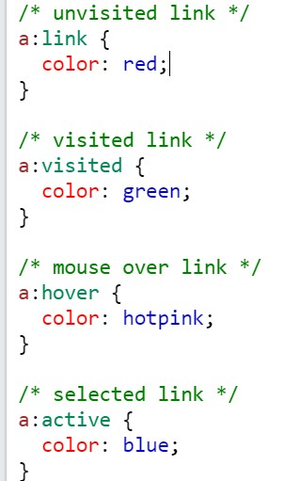

Link:class represents an element that has not yet been visited.
visited CSS pseudo-class applies once the link has been visited by the user. Active pseudo class is to show that the element is in active state.

display:none , visibility:hidden?
Both are used to hide the elements but the only difference is occupying the space. Display none will not Occupy the space , but visibility hidden will occupy the space.

Display:block,display:none?

Display:none; means the element will not be displayed, and Display:block; means the element is displayed as a block-level element
flexbox and grid?

flexbox was designed for layout in one dimension - either a row or a column. Grid was designed for two-dimensional layout - rows, and columns at the same timesgtc

Float left and float right?
Float left moves elements to the left, float right will move elements to the right

Position Relative and position Absolute?
Position : absolute
Position: sticky
Position: fixed
Position: relative
Position: static

If the element is Positioned relative to its normal position and if the element is positioned absolutely to the position of parent.
An element with position: sticky; is positioned based on the user's scroll position

NGRX STORE MODULE :
Ngrx store is used to maintain the state management. by Using store states, actions, and reducers in NgRx
Actions are methods dispatched by the component when an event is called.
To trigger an action, we use the reducers Inorder to work with ngrx store npm install --save @ngrx/store and then we have to create interface
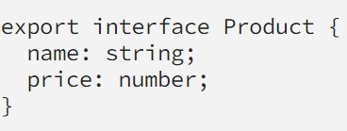
And then we need to create reducer by importing Action from ngrx store and it will have state and action.type - and also by default we can maintain state
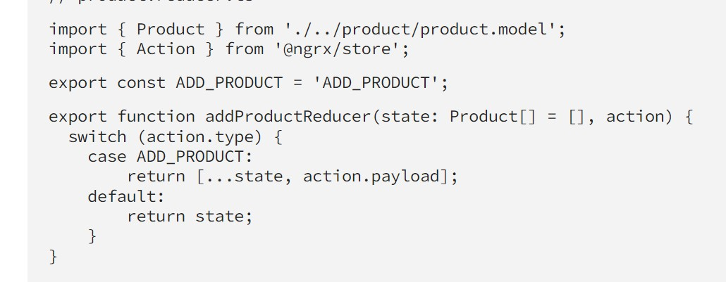
And then in root module we have to register StoreModule by passing reducer to forRoot method
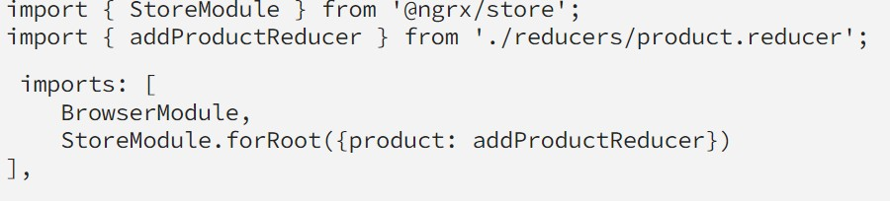
And in component we can dispatch the data by injecting store service from @ngrx/store
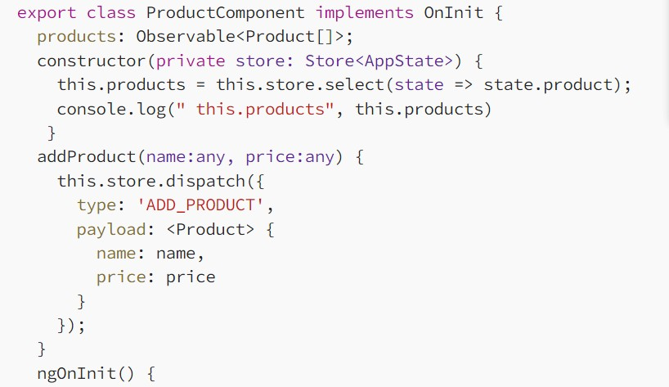

install bootstrap in angular?

Bootstrap is a framework and It supports responsive design by adjusting the styles based on the different types of device sizes.

Inorder to install bootstrap in angular application

npm install bootstrap
Then in angular.json file in styles property we need configure that
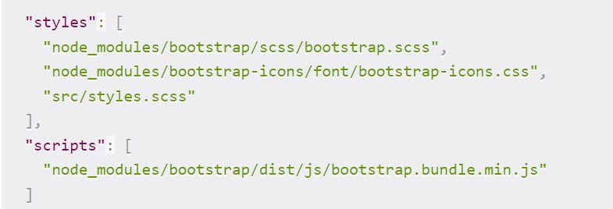

types of layout available in Bootstrap?
- Fluid Layout: Fluid layout is used when you want to create a app that is
100% wide and use up all the width of the screen
- Fixed Layout: For a standard screen you will use fixed layout (940 px) option
●
Few Important Classes from bootstrap :

container and container-fluid

The only difference between container-fluid and container is that the container is not full-width on larger screens. The container is a fixed width that's centered with large margins on the sides. container-fluid doesn't resize, it's always 100% width.

row :
Bootstrap's grid system allows up to 12 columns across the page by using row
class.
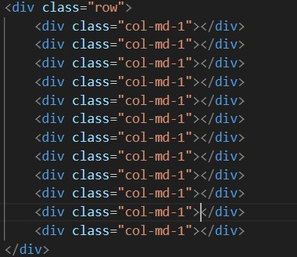
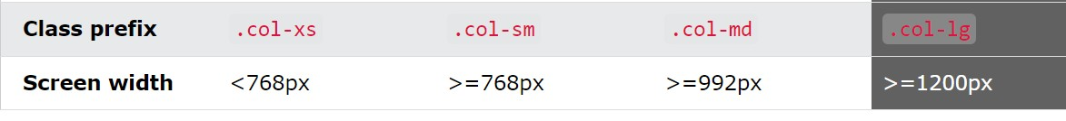

Button classes
.btn
.btn-primary
.btn-secondary

Alert Classes
.alert
.alert-success
.alert-danger

Form Classes:
form-group form-control Angular Material:
In order to work with angular material we have install by using the cmd npm install @angular/material

Button : <button mat-button>Click me!</button>

Forms : need to import MatInputModule in root module and need use mat-form-field , matInput , mat-datepicker

import {MatInputModule} from '@angular/material/input';
<form class="example-form">
<mat-form-field class="example-full-width">
<input matInput placeholder="Favorite food" value="Sushi">
</mat-form-field>

<mat-form-field class="example-full-width">
<textarea matInput placeholder="Leave a comment"></textarea>
</mat-form-field>
</form>

Date Picker : import {MatDatepickerModule} from
'@angular/material/datepicker';

<mat-form-field>
<mat-datepicker #picker></mat-datepicker>
</mat-form-field>

<ng-template></ng-template>
Ng-template is a container to group the elements. It will not render it in the dom or do not disturb the styles . It helps to create dynamic templates for example in
order to load the elseBlock of ngIf .
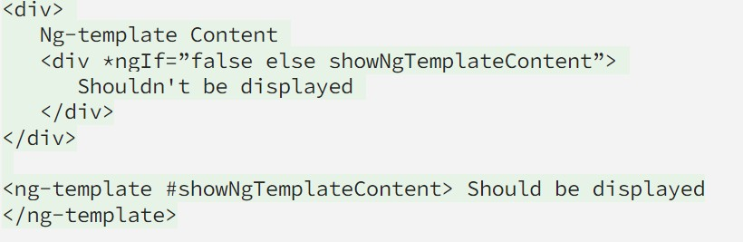
<ng-container></ng-container>
Ng-container is just a container to group the elements- but it will not render in the
DOM - we will use this for structural Directives like *ngFor and *ngIf
<ng-content></ng-content>
Ng-content it is placeholder for projected content

UNit Testing :
Yes i have written the test cases also - but by taking the reference of other files
which are written by someone or going through documents In order to run we can use this cmd : ng test fewFunctions in unit testing . like expect , toEqual , toBeTruthy , toBeFalsy

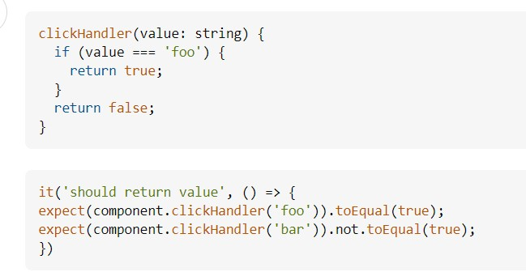

Interface :
Interface is a specification that identifies a related set of properties and methods to be implemented by a class. So basically using interface you can set some basic rules for your properties and methods using class.
Sometime we are creating an object array with a specific data type field like id has to be integer or number, name has to be string value, birth of date have date data type data. but sometimes we might make a mistake and set the string value instead of integer or number then it cought problem and your app will show you an error. But if you use the interface then it will solve problems when you write code on your IDE. IDE will show you errors quickly where there is a problem.

To define interface :
export interface Student { id: number;
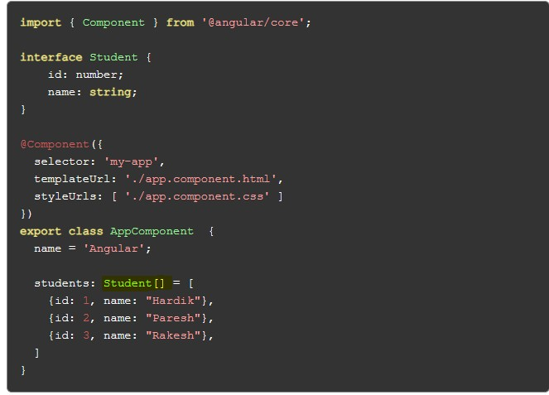

name:

string;

}

What are the features in typescript?

Spread Operator and Rest Operator
Spread operators allow us to expand an array or object into its individual elements, while rest operators allow us to condense multiple elements into a single array or object.
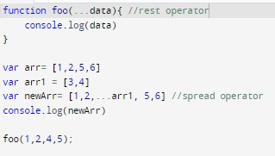
Arrow Functions
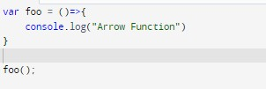
Ternary operator
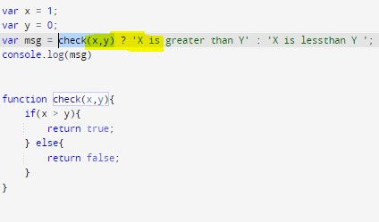
Optional Parameters
Any Data Type
Nullish Coalescing Operator
Interface
Template strings
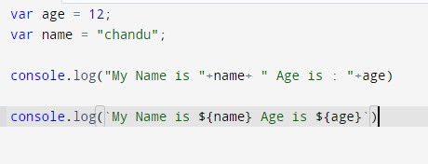

What is a first class function ?

In Javascript - functions are the first class objects -First class functions means that language functions are treated like a variable .

For example, in such a language, a function can be passed as an argument to other functions, can be returned by another function and can be assigned as a value to a variable.

Debouncing: Debouncing is a technique where you delay the execution of a function until after a certain amount of time has passed. This is useful if you have a frequently used function—say, a scroll or resize event listener—and don’t want to trigger it too frequently because that might slow down the browser.

Throttling: Throttling is a similar technique to debouncing, but instead of delaying the execution of a function, it limits the rate at which a function. This is useful when a function, such as a mousemove or keydown event listener, may be called repeatedly but need not be run each time.

Arrays built in methods :
push() - push method will add one or values in array at the end var arr = [1,2,3,4] arr.push(5)
console.log(arr): //[ 1, 2, 3, 4 ,5]

unshift() - unshift method will add one or more values in array at the beginning var arr = [1,2,3,4] arr.unshift(5)
console.log(arr): //[ 5, 1, 2, 3, 4 ]

pop() - The pop() method removes (pops) the last element of an array.
var arr = [1,2,3,4] arr.pop()
console.log(arr): //[ 1, 2, 3,]

shift()- The shift() method removes (pops) the first element of an array.
var arr = [1,2,3,4]
arr.shift()
console.log(arr): //[ 2, 3,4]

indexOf() - the indexOf() method is used find the index of specified value
if value is there it will return index of that value If values is not there it will return -1
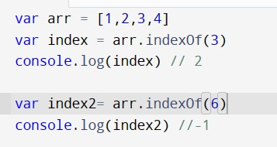

includes()
The includes() method returns true if an array contains a specified value.
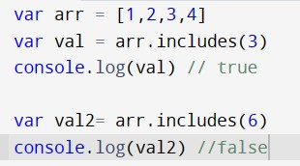

join()
The join() method returns an array as a string by concating the entire array.
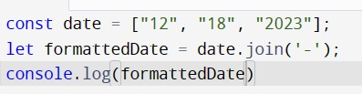
split() : the split method will return as array
Var str = “how are you”;
Var data = str.split(“ “); //splitting with space console.log(data); // [“how”, “are”, “you”]
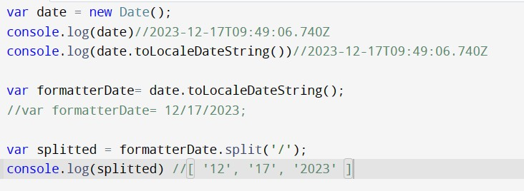 slice() splice() forEach()
map()
filter()
reduce()

some(): some() method is used to check the array if array has at least one element that will meet specific condition
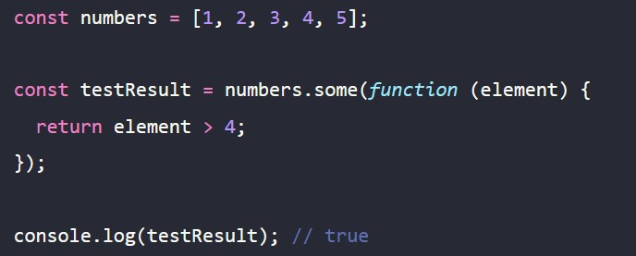
every() : In JavaScript, the array every() method checks whether all the given elements in an array are satisfying the provided condition.
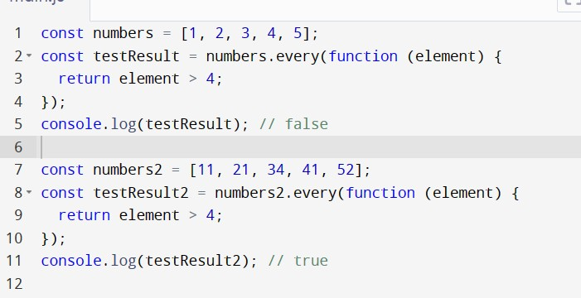

of and in – of used to loop through the values of an array and in used to loop through the keys of an object

//of example
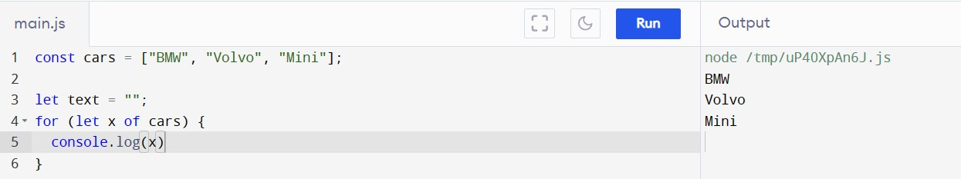

//in example
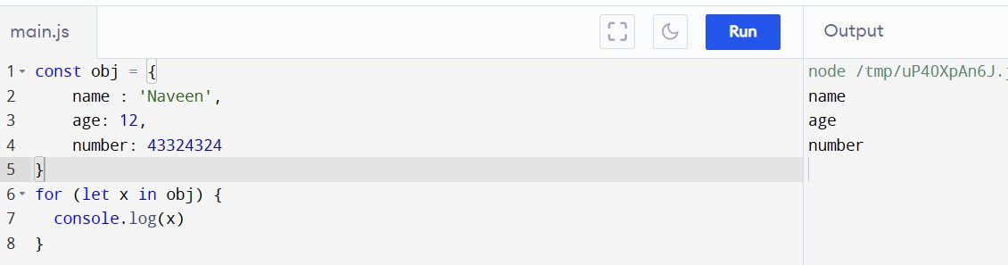

Data Types in Javascript :
String
Number,
Null - typeof null is object
Undefined - typeof undefined is undefined
Object
Symbol
Boolean

Primitive Data Types
String
Number
Null
Undefined
Symbol
Non Primitive Data types
Object
Array

Symbol :
A JavaScript Symbol is a primitive datatype just like Number, String, or Boolean. It's used to hold the unique hidden property in any object typeof Symbol() is symbol

const person = {
firstName: "John", lastName: "Doe", age: 50, eyeColor: "blue"
}; let id = Symbol('id'); person[id] = 140353;
// Now person[id] = 140353
// but person.id is still undefined

Set and Map:
Set is a collection of values - in set each value occurs only at once - set can hold any data type value

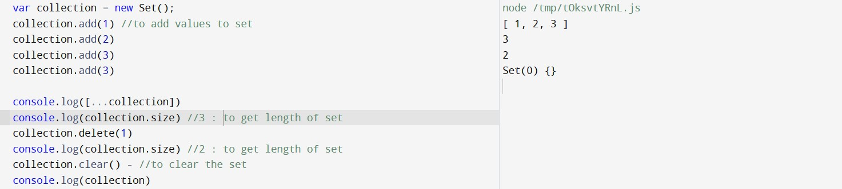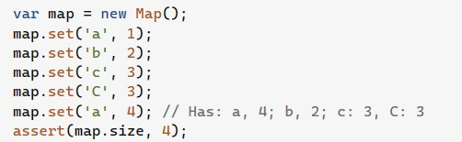

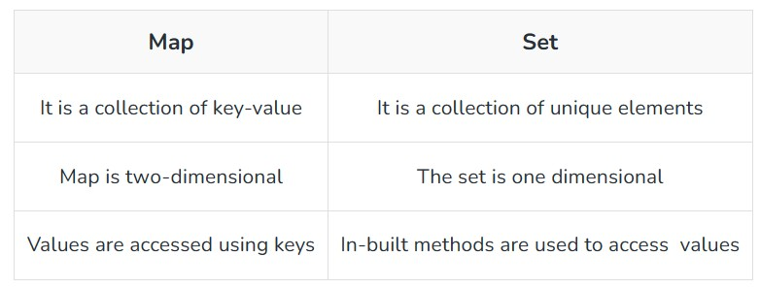
// var mainObj= {};
// var x = {};
// var y = {
// num : 1
// };
// mainObj[x]= "Sample Description";
// mainObj[y]="Other Description";
// console.log(mainObj);
// var map = new Map();
// map.set('name' , 'Naveen');
// map.set(x , 'obj1');
// map.set(y, 'obj2')
// for(let [key , obj] of map.values()){
// console.log(key , obj)
// }
// console.log(map.entries())
// for(let [key , obj] of map.entries()){
// console.log(key , obj)
// }
// console.log([...map])

Maps key will hold the value every originally its removed - it can’t be garbage collected for that we should use WeakMap

Copy / Shallow Copy Vs Deep Copy:
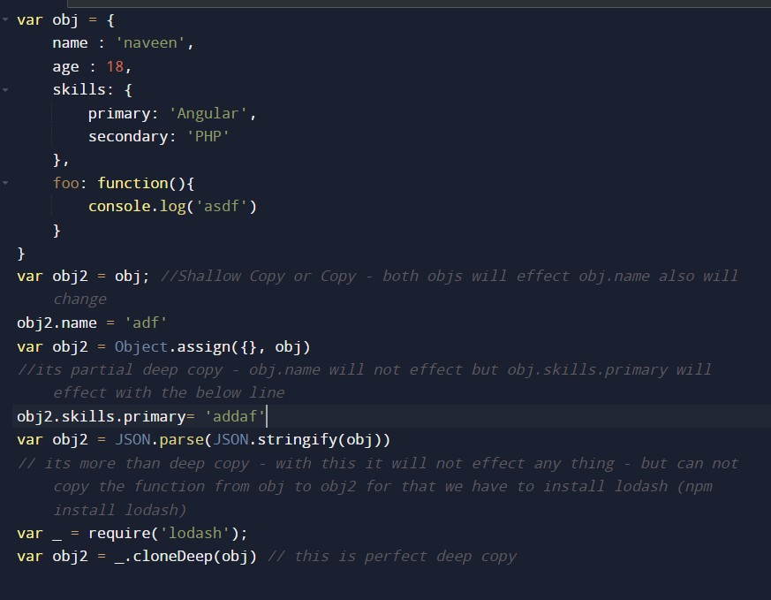
- Copying means initiating a new variable with the same value(s).
- Deep copying means that all of the values of the new variable are copied and disconnected from the original variable.
- In deep copy, a new memory allocation happens for the other entities, and reference is not copied to the other entities.

Palindrome Code:-

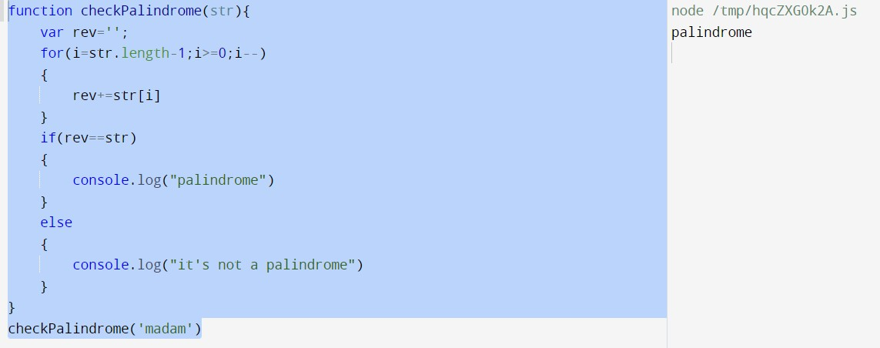

Remove Duplicate elements from an array:

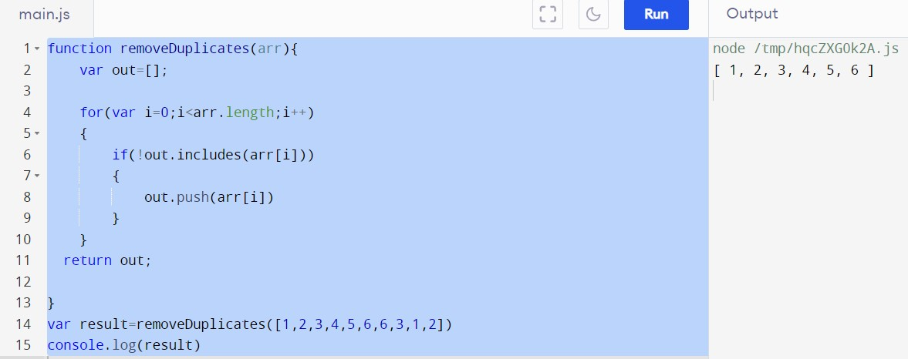

Group by Age:

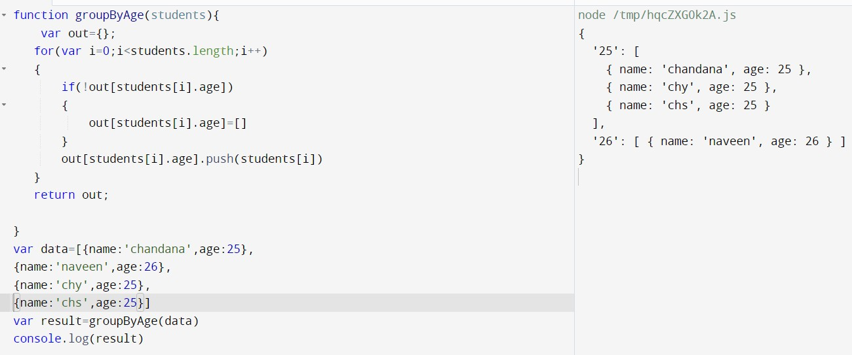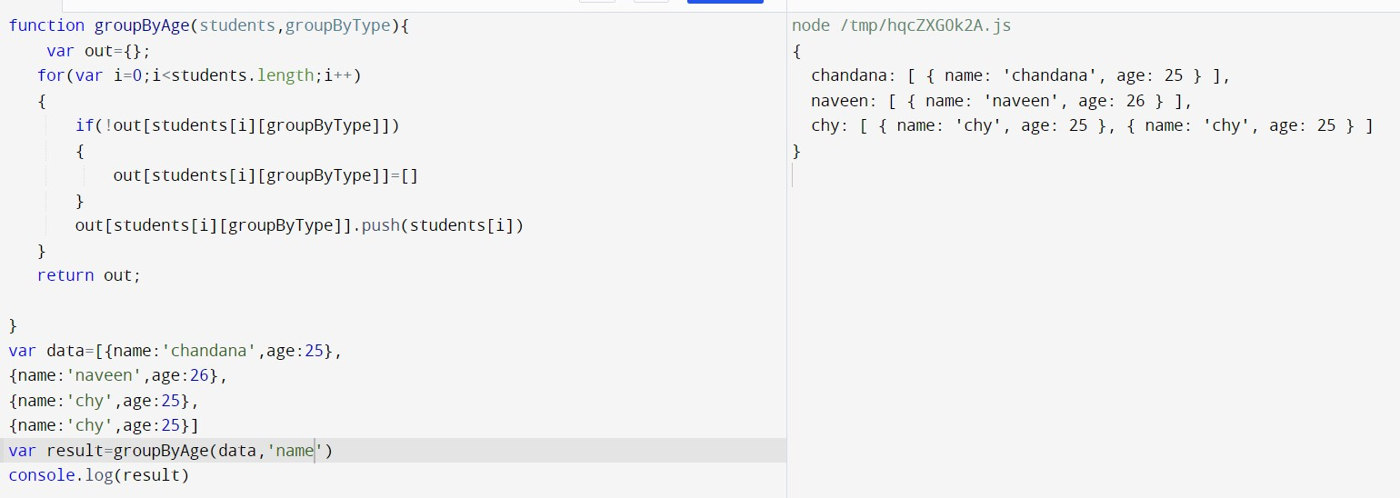

Sum of pairs:

Missing Numbers:

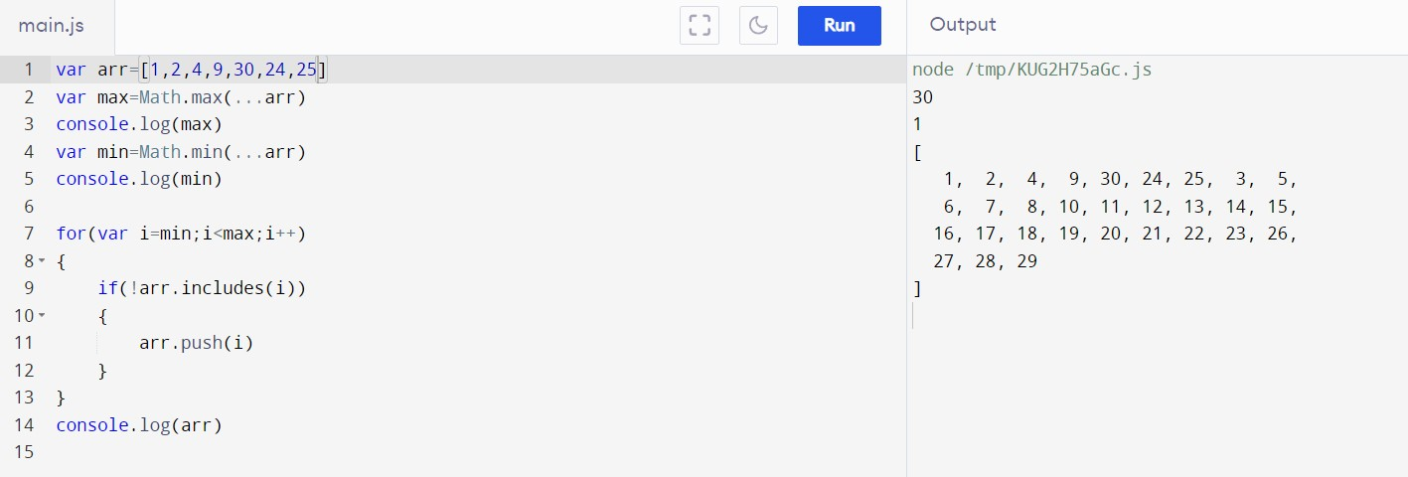
Largest Number From An Array:
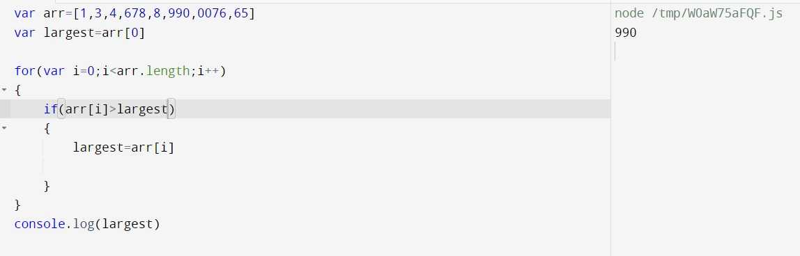
Smallest Number From An Array:

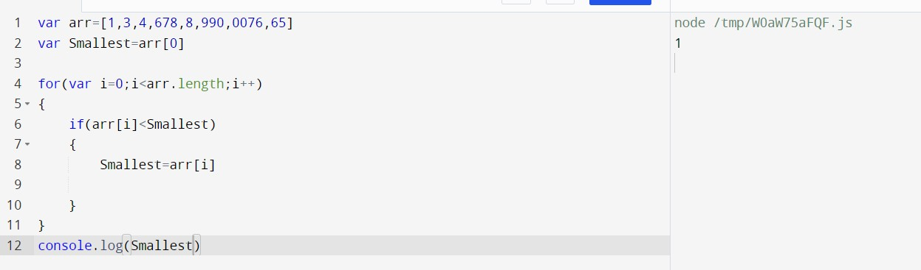

Find the frequency of elements in array

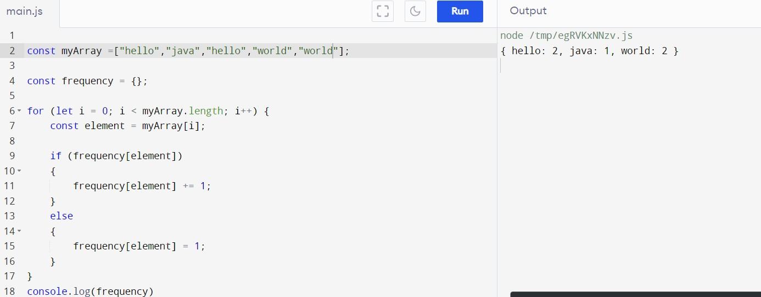

Collect books from array of objects and return collection of books as an array

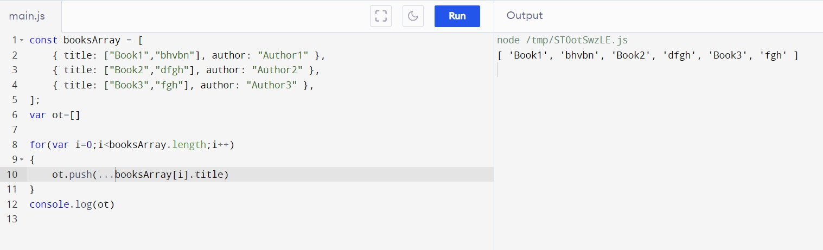

Print all duplicate elements of an array

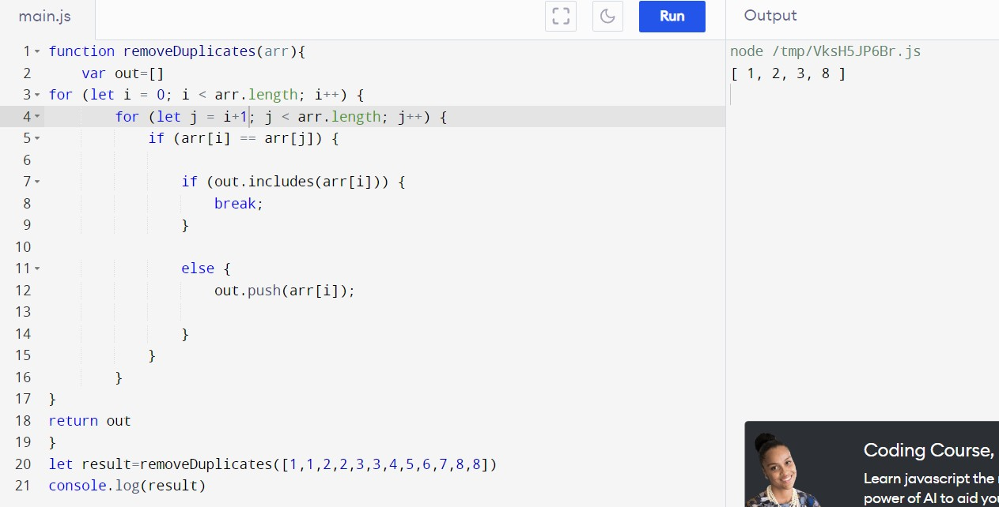

Fibonacci Series:

flattenArray
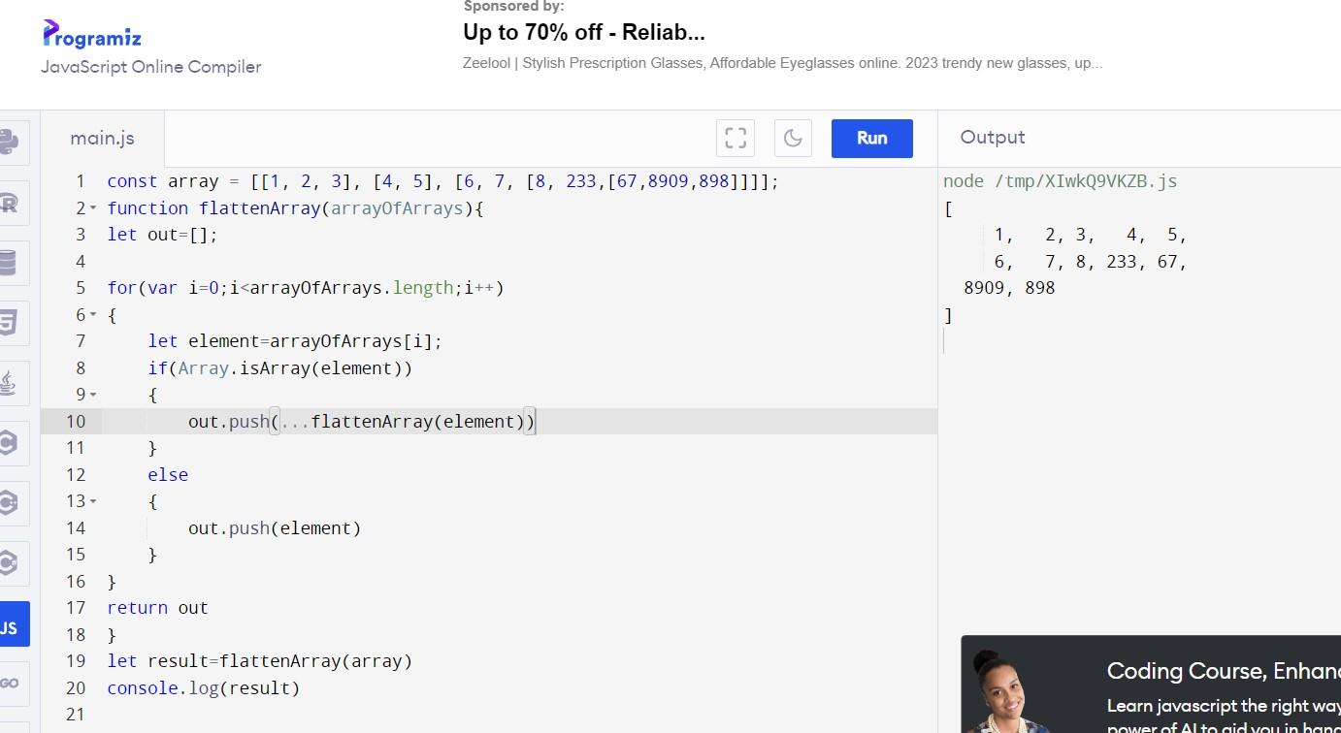

GIT
- VCS & Git Repo → VCS → Version Control System.
- Staging Area & Commits
- Branches
- Issues & PR’s
Commands:
- git
○ To check if you have installed Git or not, pass the command git in the command prompt. It will give some commands if available.
Repository/Repo:
- It is just like a folder or project folder.
Local Repo:
- A local repo is a Git repository stored on your own computer. It tracks changes before pushing them to a remote repo (GitHub, GitLab).
git init (cmd):
- git init initializes a new local Git repository in your project directory.
- Creates a hidden .git folder to track changes.
git status (cmd):
- git status shows the current state of your working directory and staging area.
- It helps to track untracked, modified, and staged files before committing.
Working Directory:
- It is a folder where we are actively editing files. (Untracked in git status).
Staging Area:
- The staging area (also called index) is where changes are prepared (staged) before committing.
- It allows you to control what gets committed, preventing accidental commits of unfinished work.
git add (cmd):
- git add moves changes from the working directory to the staging area (prepares for commit).
- Without git add, changes won't be included in the next commit. ● Example: git add filename git commit (cmd):
- git commit saves staged changes to the local repository with a message.
- Example: git commit -m "Commit message"
How to Create a Repository on GitHub?
- Go to GitHub and log in.
- Click New Repository (icon in the top right).
- Enter a Repository Name (e.g., my-project).
- Choose Public (everyone) or Private (only for you).
- Click Create Repository.
git remote origin (cmd):
- git remote origin is the reference to the remote repository URL. ● Example: git remote add origin <repo-url> git push origin main (cmd):
- git push uploads local commits to a remote repository. ● It updates the remote branch with your changes.
- Example: git push origin branch(main) git branch (cmd):
- To check the branches in a repository.
  - Example: git branch
Branches:
- Branches allow you to work on different features or fixes without affecting the main code.
- The default branch is usually main (or master).
Switch to a Branch:
- Command: git checkout BranchName
Create a Branch:
- Command: git checkout -b NewBranchName
Pull Request (PR):
- A pull request (PR) is used to merge changes from one branch to another branch (your main).
- It allows code review, collaboration, and discussion before merging.
Steps to Create a Pull Request: 1. Push your branch to GitHub.
  - Example: git push origin BranchName
2. Go to GitHub.
○ Compare pull request.
○ Add title & description of the changes.
○ Create pull request.
Code Review & Merge PR:
- Team members review the code and suggest changes.
- After approval, merge the pull request.
- Delete the branch if no longer needed.
Fork:
- Forking creates a copy of someone else’s repository under your GitHub account.
- It lets you modify the code without affecting the original repository. git clone (cmd):
- git clone is used to copy (clone) a remote repository to your local system.
- It downloads the entire repo, including history, branches, and files.
- Command: git clone <repo-url>
Merge Conflicts:
- A merge conflict happens when two branches modify the same part of a file differently.
- Git can’t automatically merge and asks you to resolve it.
git pull (cmd):
- git pull fetches new changes from a remote repository and merges them into your local branch.

